# Multiple Star Astrometry

Multiple Star Astrometry 1

Double Star Resources 4

Bootes Double Stars 6

Xi Boo 6

44 Boo 7

Corona Borealis Double Stars 7

Sig CrB 7

Eta CrB 9

Gam CrB 9

Zet CrB 10

Hercules Double Stars 11

Zeta Hercules 11

Mu Her 12

99 Hercules 13

Alp Hercules 14

Ophiuchus Double Stars 15

70 Ophiuchus 16

Lambda Ophiuchus 17

Tau Ophiuchus 18

STF 2173 18

Lyra Double Stars 19

BU 648 20

Epsilon 1 Lyrae 21

Epsilon 2 Lyrae 23

Beta Lyrae AB 24

Beta Lyrae AE 25

Beta Lyrae AF 26

Cygnus Double Stars 27

Mu Cygni 27

Lambda Cyngi 28

Delta Cygni 29

Beta Cygni 30

61 Cygni 31

Serpens Double Stars 32

Del Ser 32

Draco Double Stars 33

Mu Dra 33

17 Draconis 34

17 Dra AC 35

17 Dra CD 36

Omicron Draconis 37

Nu Draconis 38

Cassiopeia Double Stars 39

Eta Cass 39

STF 3062 40

Iot Cassiopeia Aa-B 41

Iot Cass A-C 42

Andromeda Double Stars 43

Gam And 43

Hydra Double Stars 44

Eps Hydrae 44

Lynx Double Stars 45

12 Lynx 45

Orion Double Stars 46

32 Orionis 46

Eta Orionis 47

Alnitak 48

Rigel 49

Gemini Double Stars 50

Castor 50

YY Gem 51

38 Gem 52

Eta Gem 53

Del Gem 53

Canis Major Double Stars 54

Sirius 54

Cancer Double Stars 55

Zet Cancer 55

Ursa Major Double Stars 58

Mizar 58

Xi Uma 59

Leo Double Stars 60

Gam Leo 60

Iot Leo 60

54 Leo 61

Virgo Double Stars 62

Porrima 62

## Double Star Resources

Last Updated 5/8/2019

For the time being, this document will serve primarily as an aggregation point for astrometric observations of double and multiple stars. More detailed observations and analysis of specific systems, e.g., Castor or Eps Lyr, will not be included. They may be found either as standalone documents or in other aggregations.

There are about 50 target systems in this document, probably more than half having determined orbits. Many stars show clear orbital motion and in fact errors compared to the WD6 ephemerides show decreasing cumulative errors over time. Notable missed spring observations include: Castor, Zeta Cancer, and Xi Ursa Majoris.

Some online resources are listed below:

Journal of Double Star Observations - [JDSO](http://www.jdso.org/)

Washington Double Star catalog - [USNO WDS](https://www.usno.navy.mil/USNO/astrometry/optical-IR-prod/wds/WDS)

Python code in [GitHub](https://github.com/smhill001/BinaryStars)

Future work could include:

1. Rigorously reassessing the errors around each measurement for use in weighted fits.
2. Documenting the residuals from the fits.
3. Using weighted fits rather than simple averages for the comparisons to the WD6 predictions.
4. Completing Python codes to move all plotting analysis (not data reduction and measurement) out of Excel

**(In order to get proper orientation, rotate by “rotation minus 90 degrees”, clockwise in MaximDL.)**

## Bootes Double Stars

|  |  |  |  |  |
| --- | --- | --- | --- | --- |
| **Star** | **First Obs Date** | **Last Obs Dates** | **N Obs** | **Notes** |
| Xi Boo | 2009.512 | 2009.512 | 1 | Has swept through 0 degrees of PA. |
| 44 Boo | 2009.512 | 2009.512 | 1 | Has swept through 0 degrees of PA. |

### Xi Boo

|  |  |  |  |  |  |  |  |  |  |  |  |  |  |  |  |  |  |  |  |  |  |  |  |  |  |  |  |  |  |
| --- | --- | --- | --- | --- | --- | --- | --- | --- | --- | --- | --- | --- | --- | --- | --- | --- | --- | --- | --- | --- | --- | --- | --- | --- | --- | --- | --- | --- | --- |
|  | |  |  |  |  | | --- | --- | --- | --- | | **Parameter** | **Value** | **Rate** | **Units** | | PA(O) |  |  | deg(/yr) | | PA(P) |  |  | deg(/yr) | | PA (O-P) |  |  | deg(/yr) | | Sep(O) |  |  | asec(/yr) | | Sep(P) |  |  | asec(/yr) | | Sep (O-P) |  |  | asec(/yr) | |

### 44 Boo

|  |  |  |  |  |  |  |  |  |  |  |  |  |  |  |  |  |  |  |  |  |  |  |  |  |  |  |  |  |  |
| --- | --- | --- | --- | --- | --- | --- | --- | --- | --- | --- | --- | --- | --- | --- | --- | --- | --- | --- | --- | --- | --- | --- | --- | --- | --- | --- | --- | --- | --- |
|  | |  |  |  |  | | --- | --- | --- | --- | | **Parameter** | **Value** | **Rate** | **Units** | | PA(O) |  |  | deg(/yr) | | PA(P) |  |  | deg(/yr) | | PA (O-P) |  |  | deg(/yr) | | Sep(O) |  |  | asec(/yr) | | Sep(P) |  |  | asec(/yr) | | Sep (O-P) |  |  | asec(/yr) | |

## Corona Borealis Double Stars

|  |  |  |  |  |
| --- | --- | --- | --- | --- |
| **Star** | **First Obs Date** | **Last Obs Dates** | **N Obs** | **Notes** |
| Sig CrB | 2009.512 | 2009.512 | 1 | Has swept through 0 degrees of PA. |
| Eta CrB | 2009.512 | 2013.539 | 3 | Has swept through TBD degrees of PA. |
| Gam CrB | 2007.501 | 2007.501 | 1 | Has swept through 0 degrees of PA. |
| Zet CrB | 2009.512 | 2009.512 | 1 | Fixed double |

### Sig CrB

|  |  |  |  |  |  |  |  |  |  |  |  |  |  |  |  |  |  |  |  |  |  |  |  |  |  |  |  |  |  |
| --- | --- | --- | --- | --- | --- | --- | --- | --- | --- | --- | --- | --- | --- | --- | --- | --- | --- | --- | --- | --- | --- | --- | --- | --- | --- | --- | --- | --- | --- |
|  | |  |  |  |  | | --- | --- | --- | --- | | **Parameter** | **Value** | **Rate** | **Units** | | PA(O) |  |  | deg(/yr) | | PA(P) |  |  | deg(/yr) | | PA (O-P) |  |  | deg(/yr) | | Sep(O) |  |  | asec(/yr) | | Sep(P) |  |  | asec(/yr) | | Sep (O-P) |  |  | asec(/yr) | |

### Eta CrB

|  |  |  |  |  |  |  |  |  |  |  |  |  |  |  |  |  |  |  |  |  |  |  |  |  |  |  |  |  |  |
| --- | --- | --- | --- | --- | --- | --- | --- | --- | --- | --- | --- | --- | --- | --- | --- | --- | --- | --- | --- | --- | --- | --- | --- | --- | --- | --- | --- | --- | --- |
|  | |  |  |  |  | | --- | --- | --- | --- | | **Parameter** | **Value** | **Rate** | **Units** | | PA(O) |  |  | deg(/yr) | | PA(P) |  |  | deg(/yr) | | PA (O-P) |  |  | deg(/yr) | | Sep(O) |  |  | asec(/yr) | | Sep(P) |  |  | asec(/yr) | | Sep (O-P) |  |  | asec(/yr) | |

### Gam CrB

|  |  |  |  |  |  |  |  |  |  |  |  |  |  |  |  |  |  |  |  |  |  |  |  |  |  |  |  |  |  |
| --- | --- | --- | --- | --- | --- | --- | --- | --- | --- | --- | --- | --- | --- | --- | --- | --- | --- | --- | --- | --- | --- | --- | --- | --- | --- | --- | --- | --- | --- |
|  | |  |  |  |  | | --- | --- | --- | --- | | **Parameter** | **Value** | **Rate** | **Units** | | PA(O) |  |  | deg(/yr) | | PA(P) |  |  | deg(/yr) | | PA (O-P) |  |  | deg(/yr) | | Sep(O) |  |  | asec(/yr) | | Sep(P) |  |  | asec(/yr) | | Sep (O-P) |  |  | asec(/yr) | |

### Zet CrB

|  |  |  |  |  |  |  |  |  |  |  |  |  |  |  |  |  |  |  |  |  |  |  |  |  |  |  |  |  |  |
| --- | --- | --- | --- | --- | --- | --- | --- | --- | --- | --- | --- | --- | --- | --- | --- | --- | --- | --- | --- | --- | --- | --- | --- | --- | --- | --- | --- | --- | --- |
|  | |  |  |  |  | | --- | --- | --- | --- | | **Parameter** | **Value** | **Rate** | **Units** | | PA(O) |  |  | deg(/yr) | | PA(P) |  |  | deg(/yr) | | PA (O-P) |  |  | deg(/yr) | | Sep(O) |  |  | asec(/yr) | | Sep(P) |  |  | asec(/yr) | | Sep (O-P) |  |  | asec(/yr) | |

## Hercules Double Stars

|  |  |  |  |  |
| --- | --- | --- | --- | --- |
| **Star** | **First Obs Date** | **Last Obs Dates** | **N Obs** | **Notes** |
| Zet Her | 2008.537 | 2018.726 | 9 | Has swept through TBD degrees of PA. |
| Mu Her | 2011.693 | 2011.693 | 1 | Fixed double |
| 99 Her | 2008.709 | 2008.709 | 1 | Has swept through 0 degrees of PA |
| Alp Her | 2008.537 | 2011.616 | 3 |  |

### Zeta Hercules

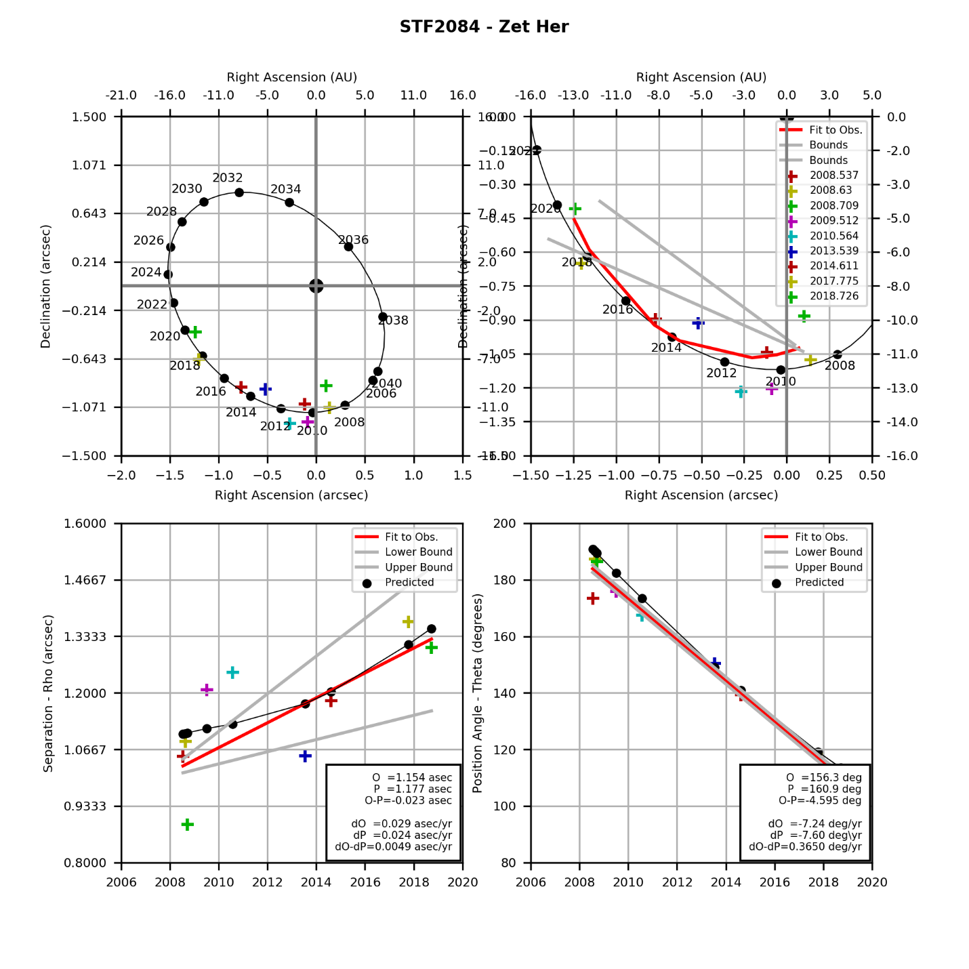

STF2084.png (created by StevesBinaryPlotterV05.py on 12/19/2014)

### Mu Her

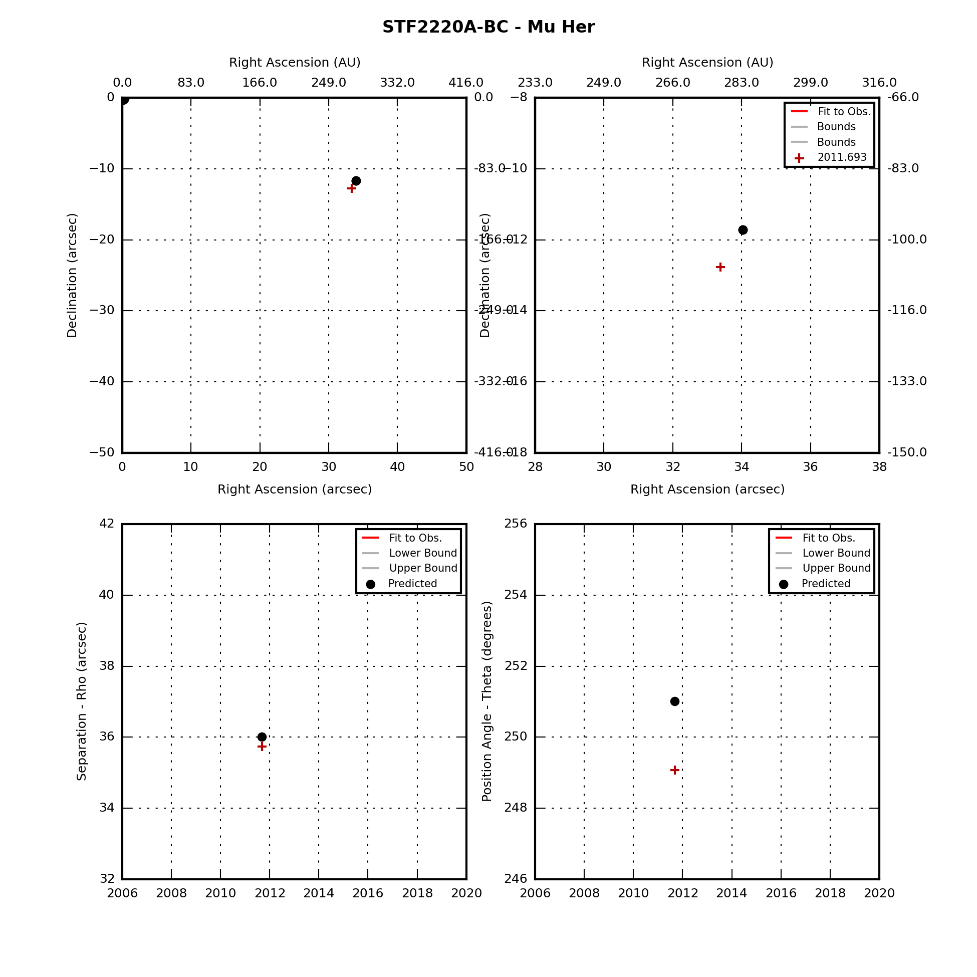

### 99 Hercules

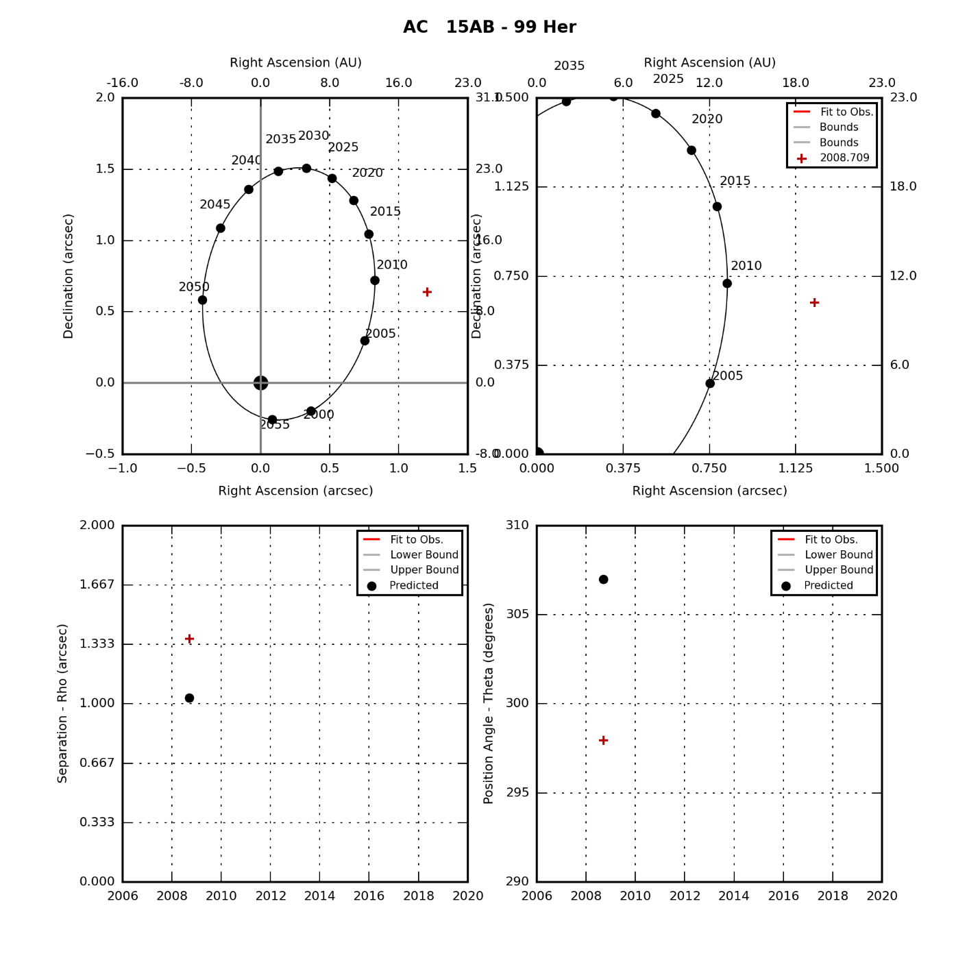

### Alp Hercules

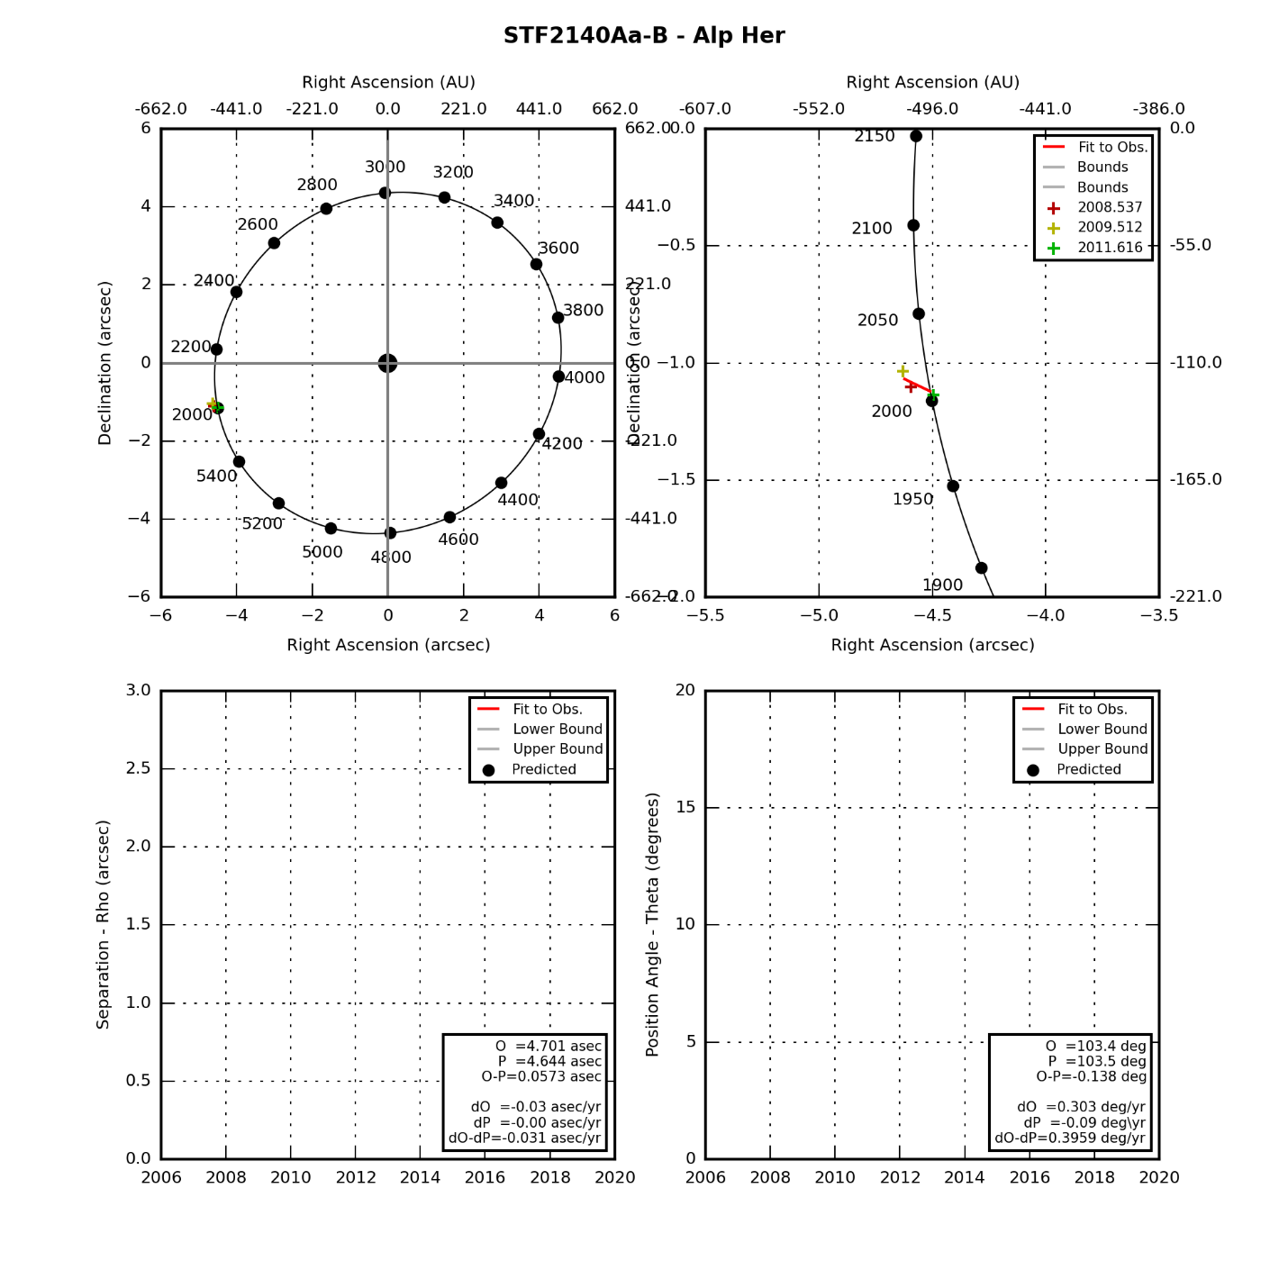

## Ophiuchus Double Stars

|  |  |  |  |  |
| --- | --- | --- | --- | --- |
| **Star** | **First Obs Date** | **Last Obs Dates** | **N Obs** | **Notes** |
| 70 Oph | 2008.537 | 2017.775 | 8 | Has swept through TBD degrees of PA. |
| Lam Oph | 2009.512 | 2014.611 | 3 | Fixed double |
| Tau Oph | 2014.611 | 2014.611 | 1 | Has swept through 0 degrees of PA. |
| STF 2173 | 2008.709 | 2008.709 | 1 | Has swept through 0 degrees of PA. |

### 70 Ophiuchus

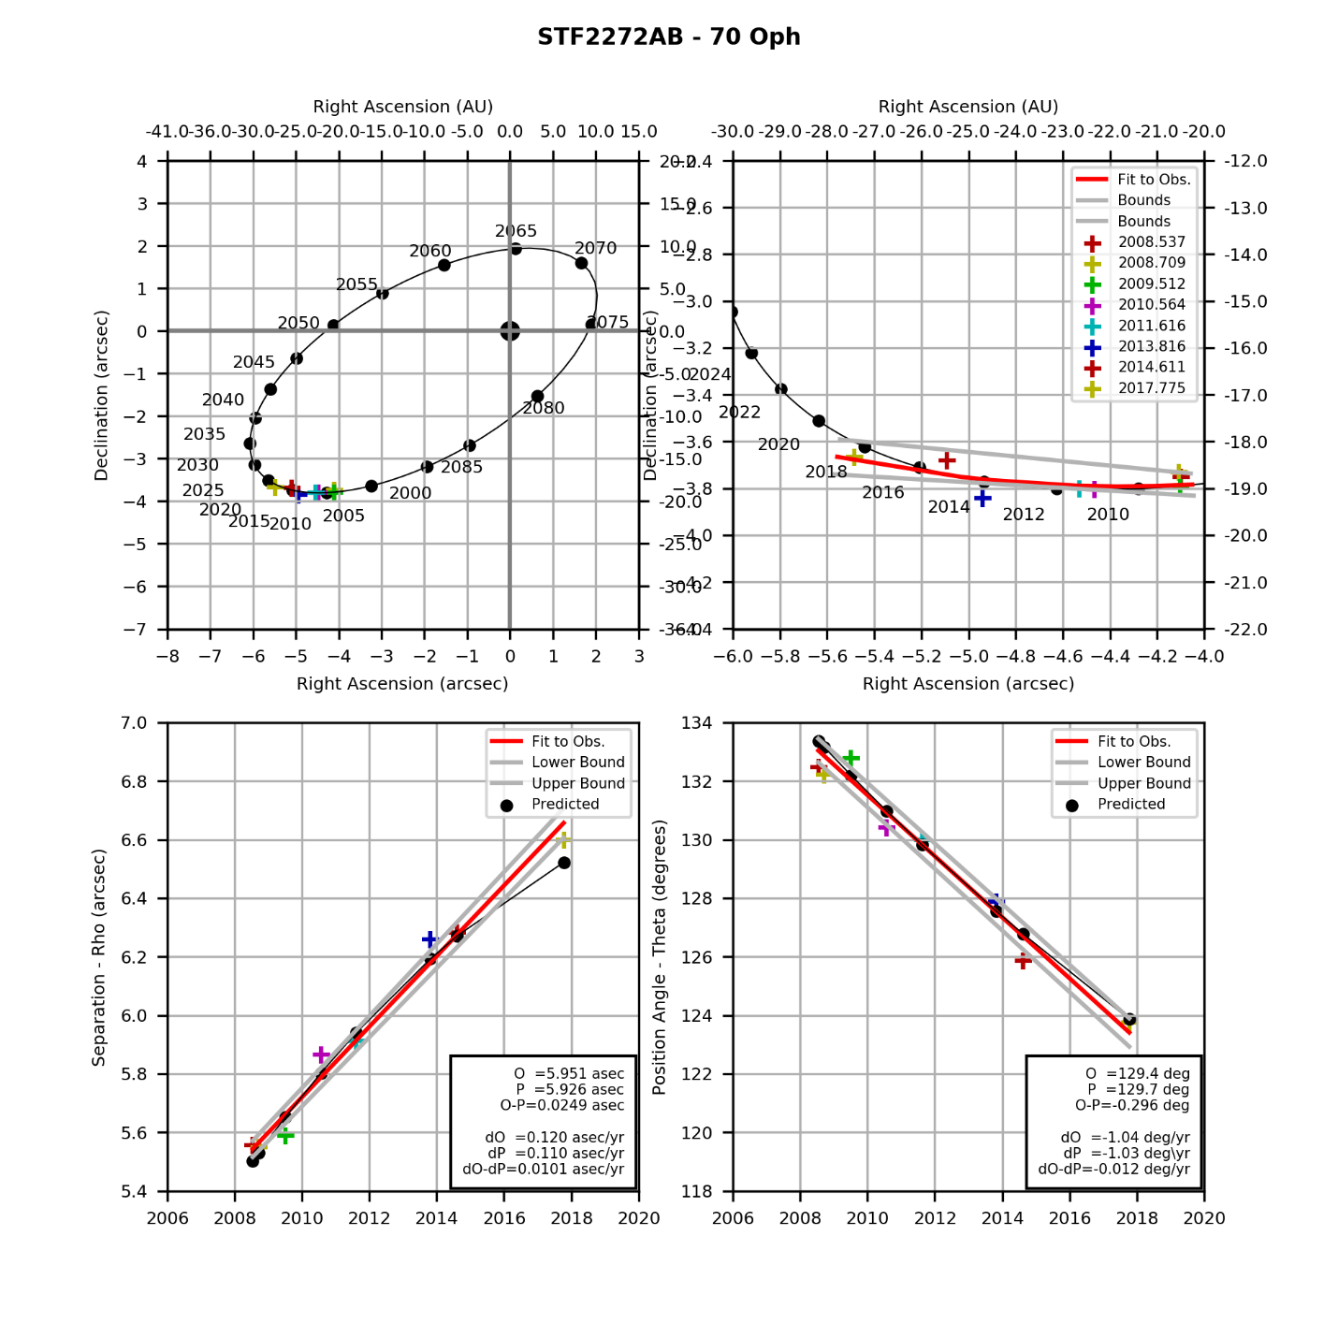

STF1110AB.png (created by StevesBinaryPlotterV05.py on 12/19/2014)

### Lambda Ophiuchus

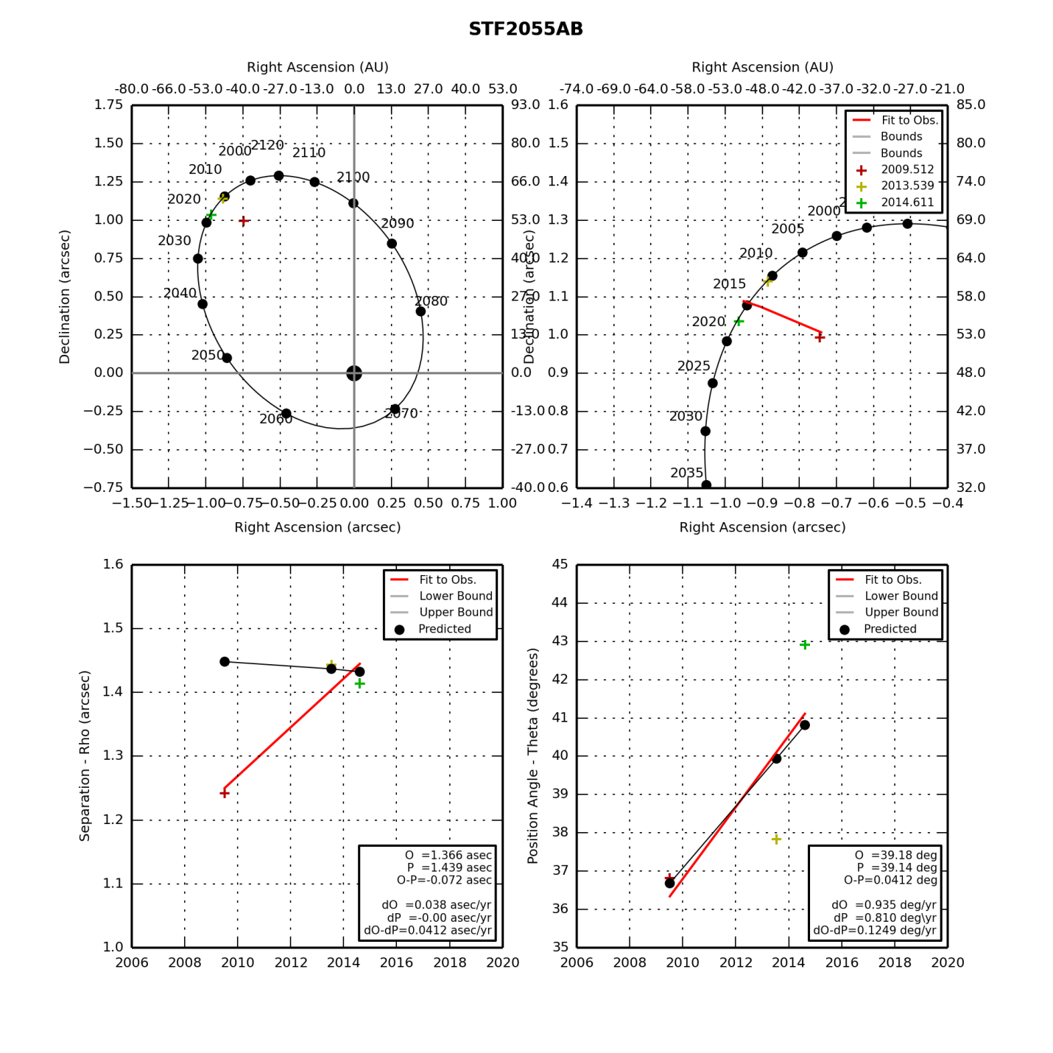

STF2055AB.png (created by StevesBinaryPlotterV05.py on 12/19/2014)

### Tau Ophiuchus

|  |  |  |  |  |  |  |  |  |  |  |  |  |  |  |  |  |  |  |  |  |  |  |  |  |  |  |  |  |  |
| --- | --- | --- | --- | --- | --- | --- | --- | --- | --- | --- | --- | --- | --- | --- | --- | --- | --- | --- | --- | --- | --- | --- | --- | --- | --- | --- | --- | --- | --- |
|  | |  |  |  |  | | --- | --- | --- | --- | | **Parameter** | **Value** | **Rate** | **Units** | | PA(O) |  |  | deg(/yr) | | PA(P) |  |  | deg(/yr) | | PA (O-P) |  |  | deg(/yr) | | Sep(O) |  |  | asec(/yr) | | Sep(P) |  |  | asec(/yr) | | Sep (O-P) |  |  | asec(/yr) | |

### STF 2173

|  |  |  |  |  |  |  |  |  |  |  |  |  |  |  |  |  |  |  |  |  |  |  |  |  |  |  |  |  |  |
| --- | --- | --- | --- | --- | --- | --- | --- | --- | --- | --- | --- | --- | --- | --- | --- | --- | --- | --- | --- | --- | --- | --- | --- | --- | --- | --- | --- | --- | --- |
|  | |  |  |  |  | | --- | --- | --- | --- | | **Parameter** | **Value** | **Rate** | **Units** | | PA(O) |  |  | deg(/yr) | | PA(P) |  |  | deg(/yr) | | PA (O-P) |  |  | deg(/yr) | | Sep(O) |  |  | asec(/yr) | | Sep(P) |  |  | asec(/yr) | | Sep (O-P) |  |  | asec(/yr) | |

## Lyra Double Stars

|  |  |  |  |  |
| --- | --- | --- | --- | --- |
| **Star** | **First Obs Date** | **Last Obs Dates** | **N Obs** | **Notes** |
| BU 648 | 2008.637 | 2018.726 | 8 | Has swept through TBD degrees of PA. |
| Eps 1 Lyr | 2007.501 | 2018.726 | 11 | Has swept through TBD degrees of PA. |
| Eps 2 Lyr | 2007.501 | 2018.726 | 11 | Has swept through TBD degrees of PA. |
| Bet Lyr AB | 2007.717 | 2011.616 | 2 | Fixed multiple |
| Bet Lyr AE | 2007.717 | 2011.616 | 2 | Fixed multiple |
| Bet Lyr AF | 2007.717 | 2011.616 | 2 | Fixed multiple |

### BU 648

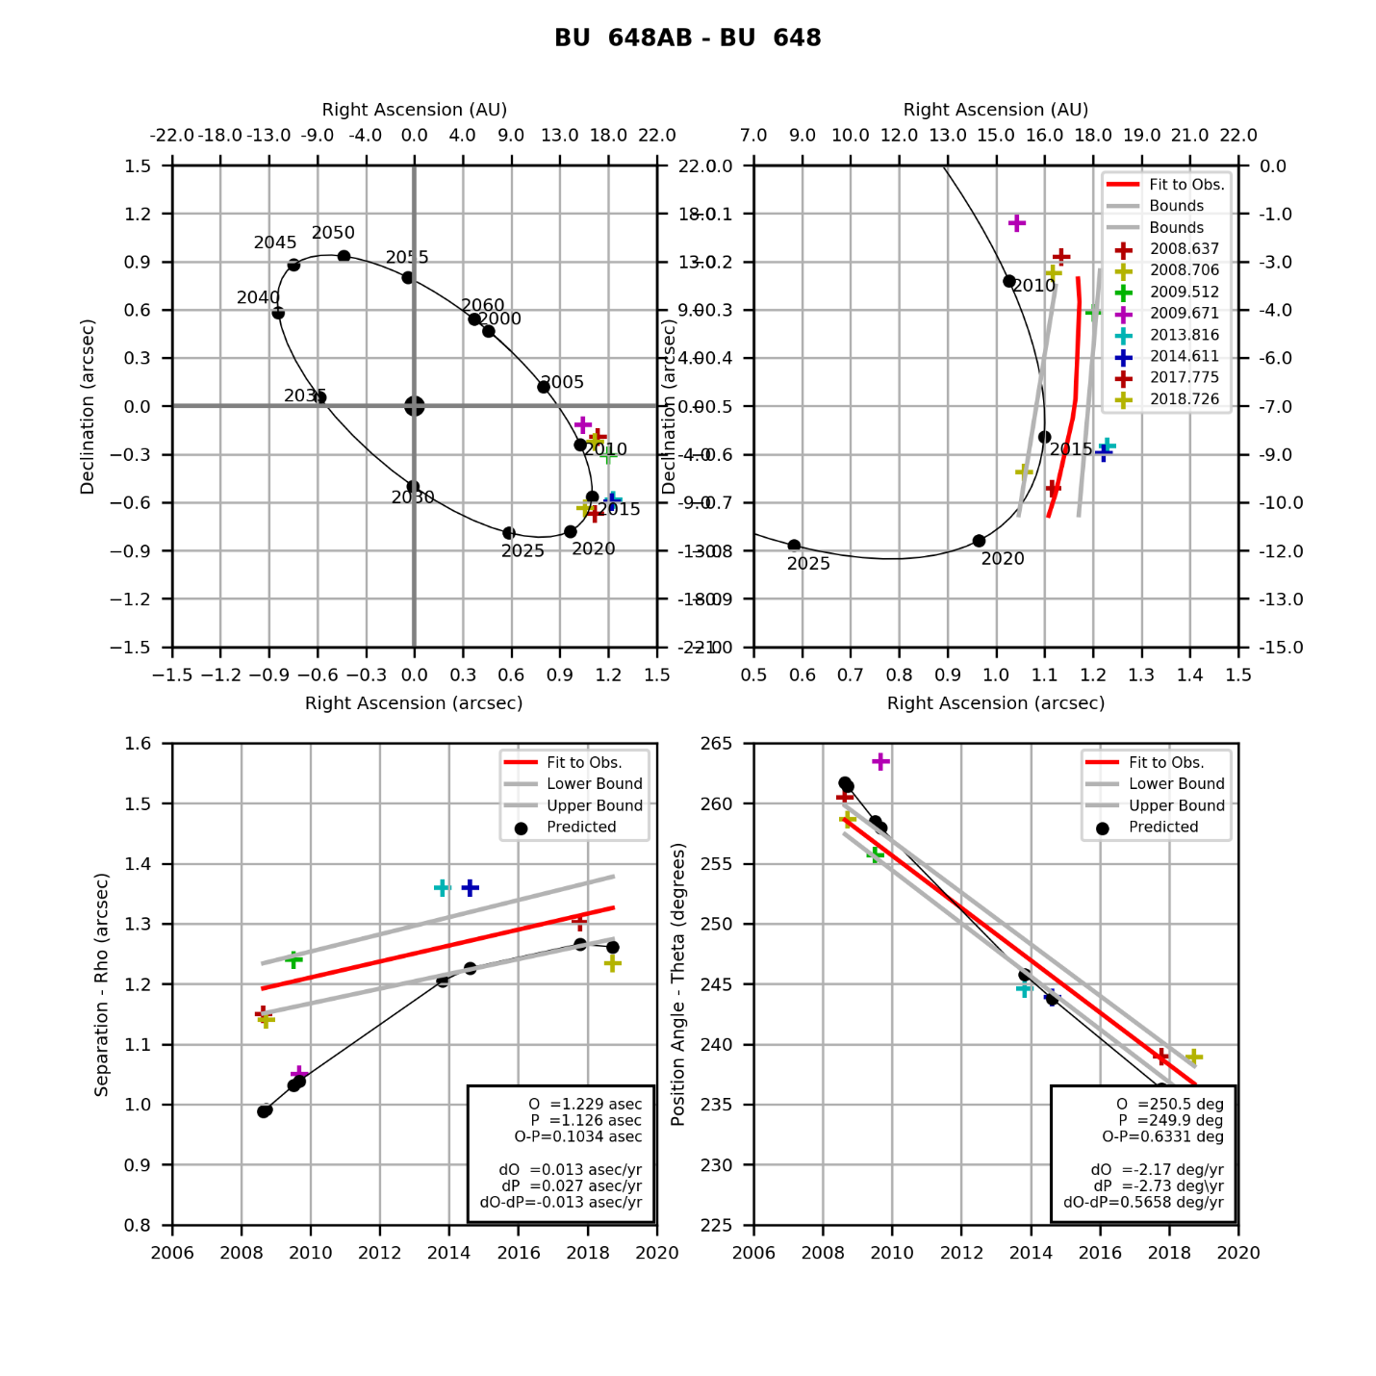

BU 648AB.png (created by StevesBinaryPlotterV05.py on 12/19/2014)

### Epsilon 1 Lyrae

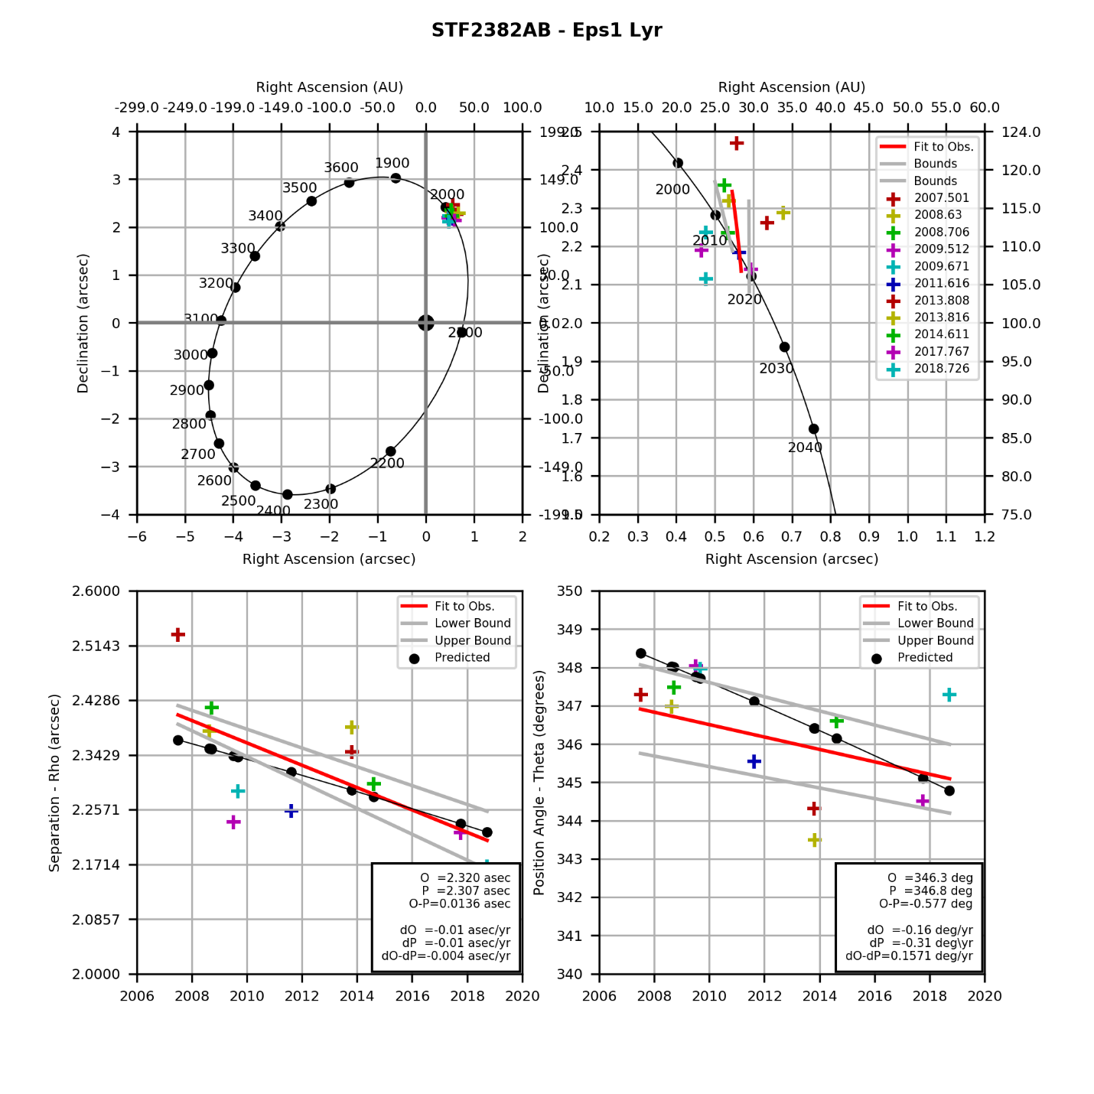

STF2382AB.png (created by StevesBinaryPlotterV05.py on 12/19/2014)

### Epsilon 2 Lyrae

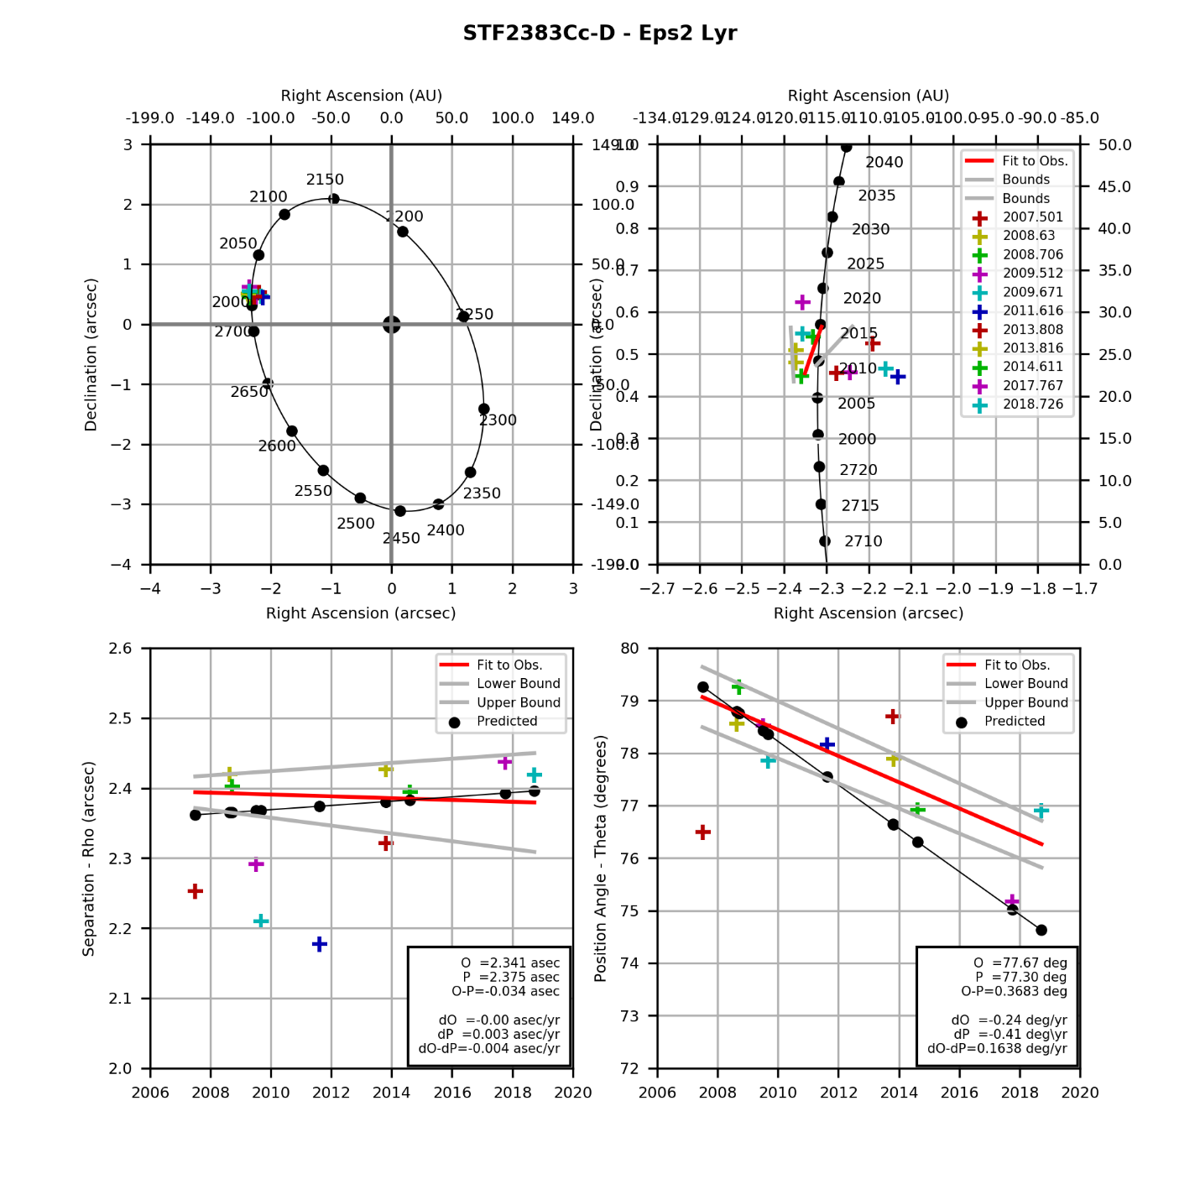

STF2383Cc-D.png (created by StevesBinaryPlotterV05.py on 12/19/2014)

### Beta Lyrae AB

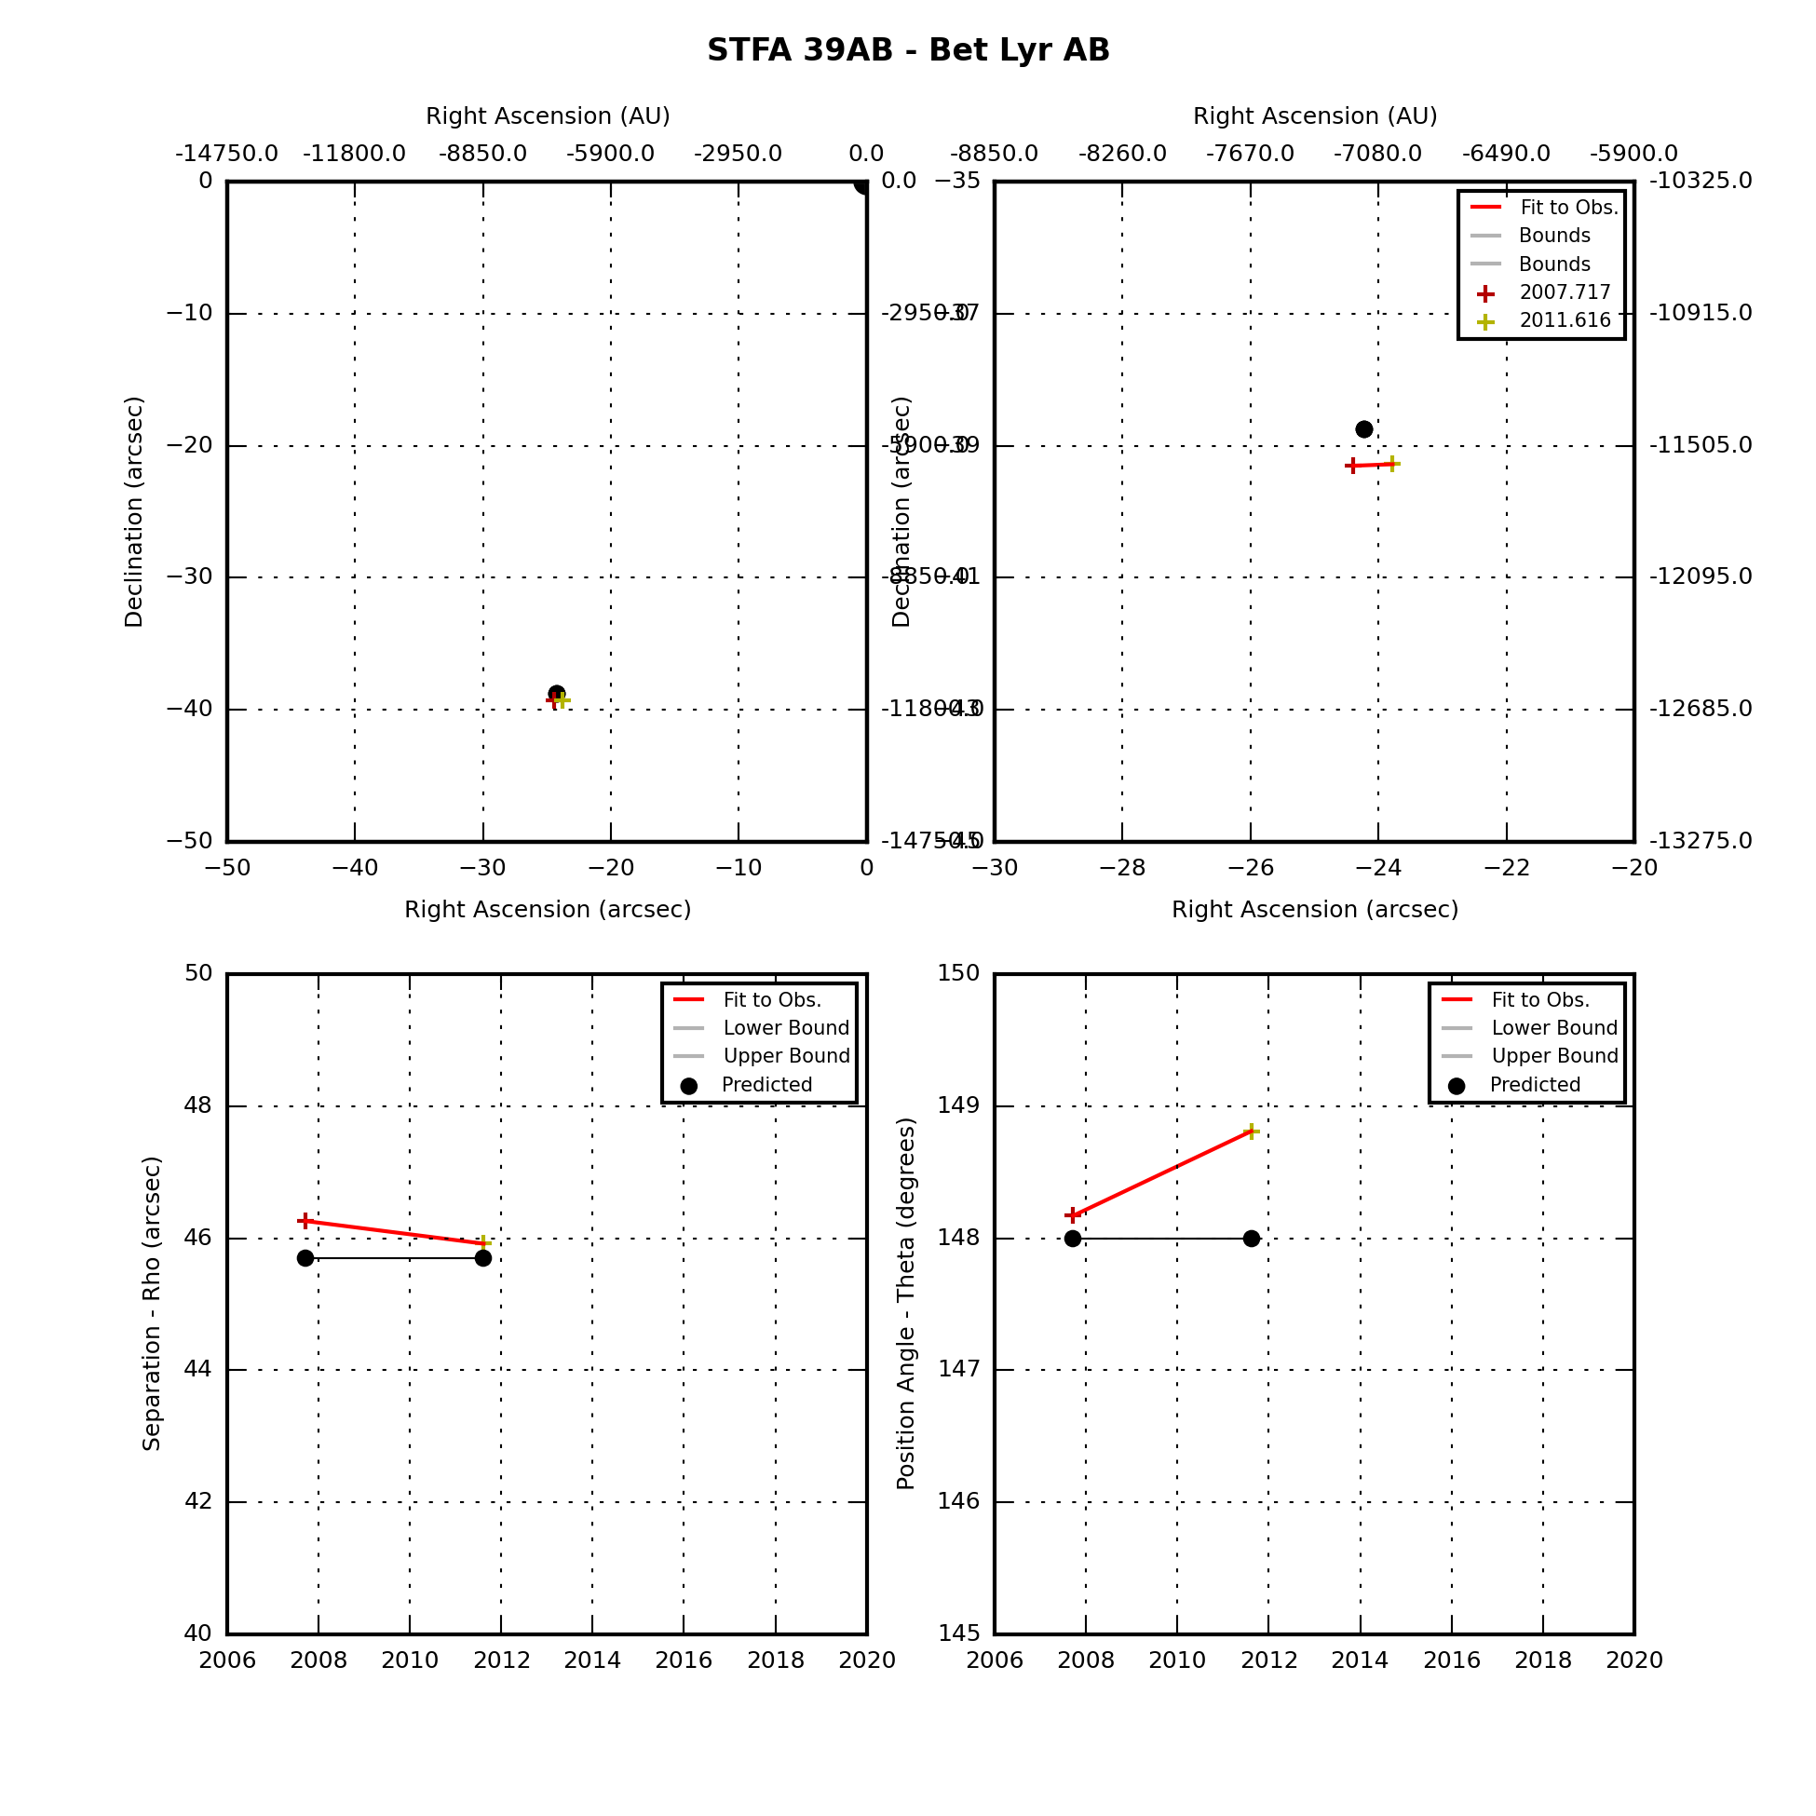

### Beta Lyrae AE

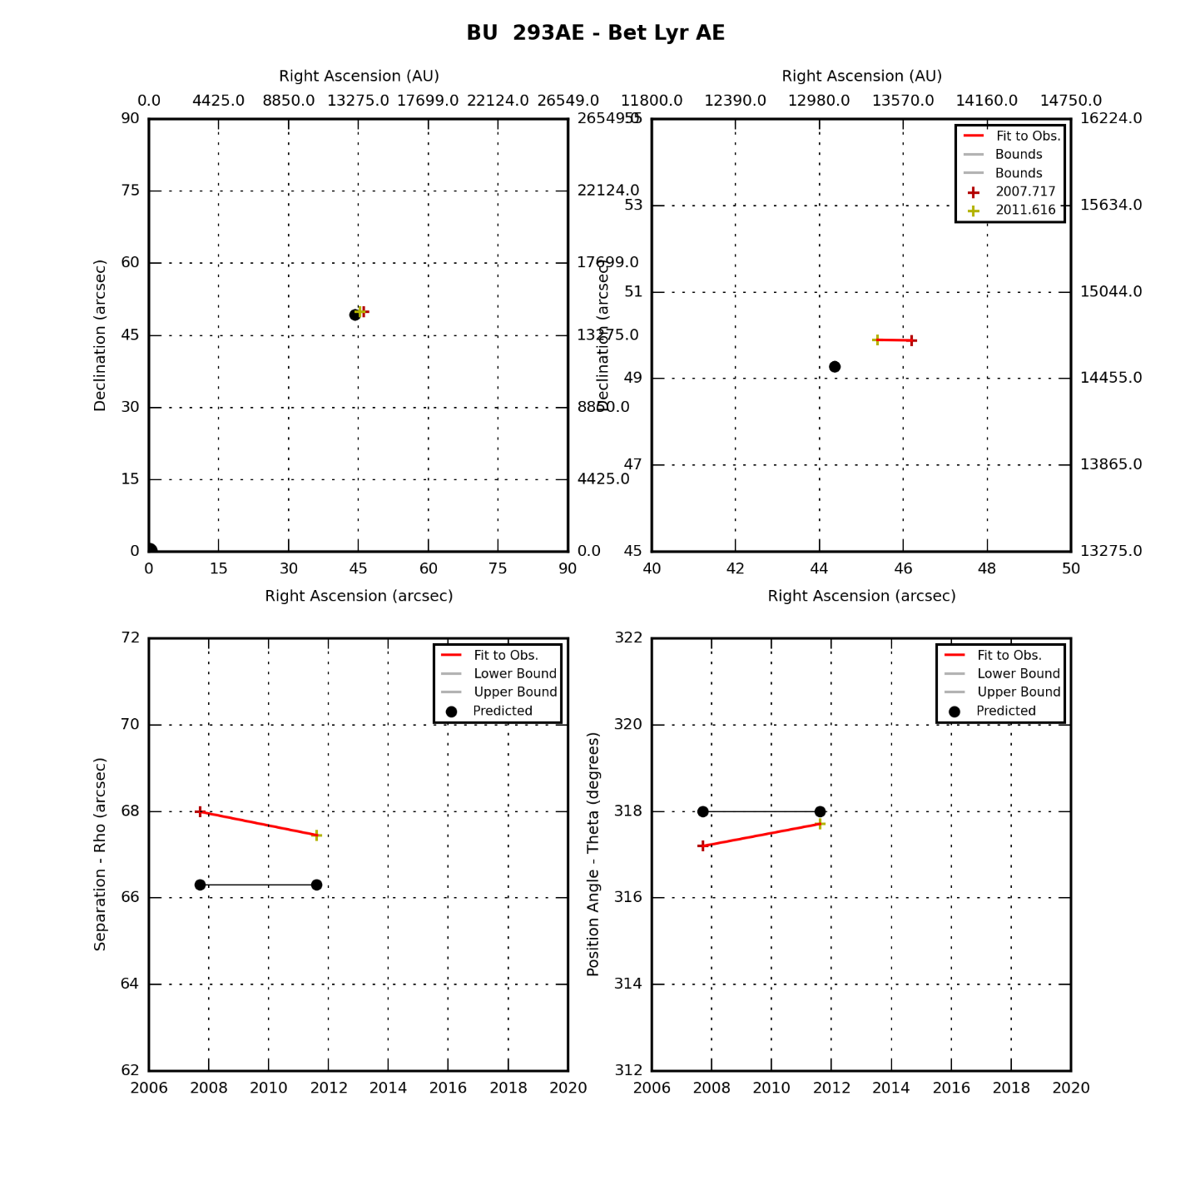

### Beta Lyrae AF

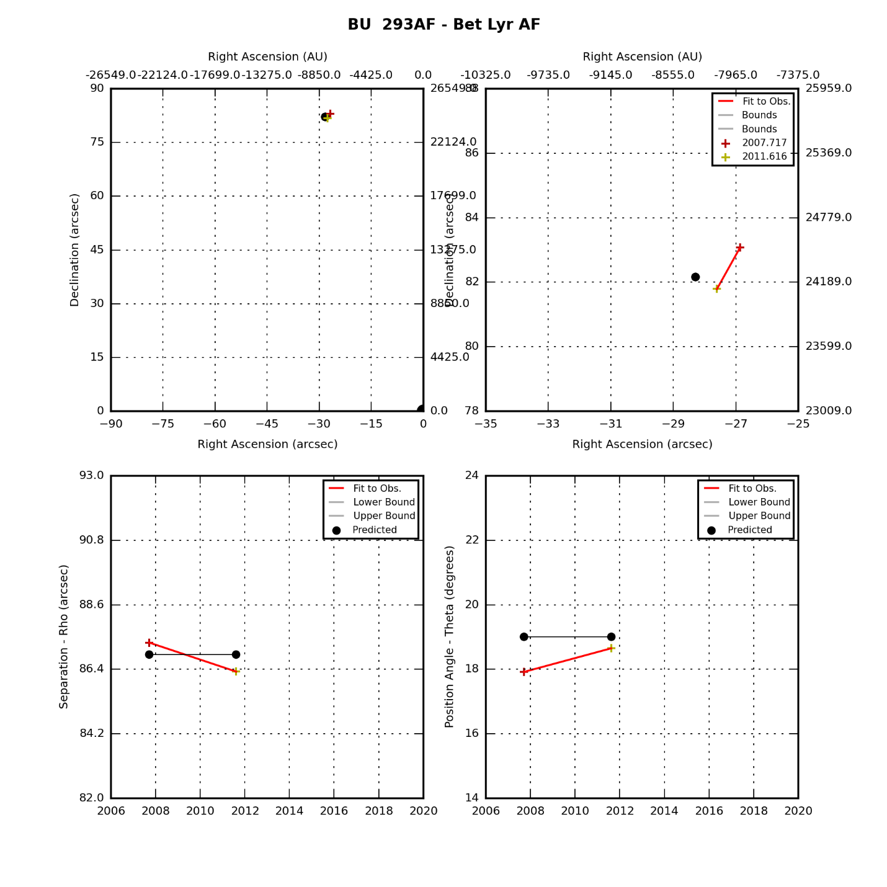

## Cygnus Double Stars

|  |  |  |  |  |
| --- | --- | --- | --- | --- |
| **Star** | **First Obs Date** | **Last Obs Dates** | **N Obs** | **Notes** |
| Mu Cyg | 2008.706 | 2018.726 | 3 | Has swept through TBD degrees of PA. |
| Lam Cyg | 2008.706 | 2018.726 | 2 | Has swept through TBD degrees of PA. |
| Del Cyg | 2008.706 | 2018.726 | 3 | Has swept through TBD degrees of PA. |
| Bet Cyg | 2008.630 | 2008.709 | 2 | Fixed double |
| 61 Cyg | 2008.706 | 2013.816 | 2 | Has swept through TBD degrees of PA. |

### Mu Cygni

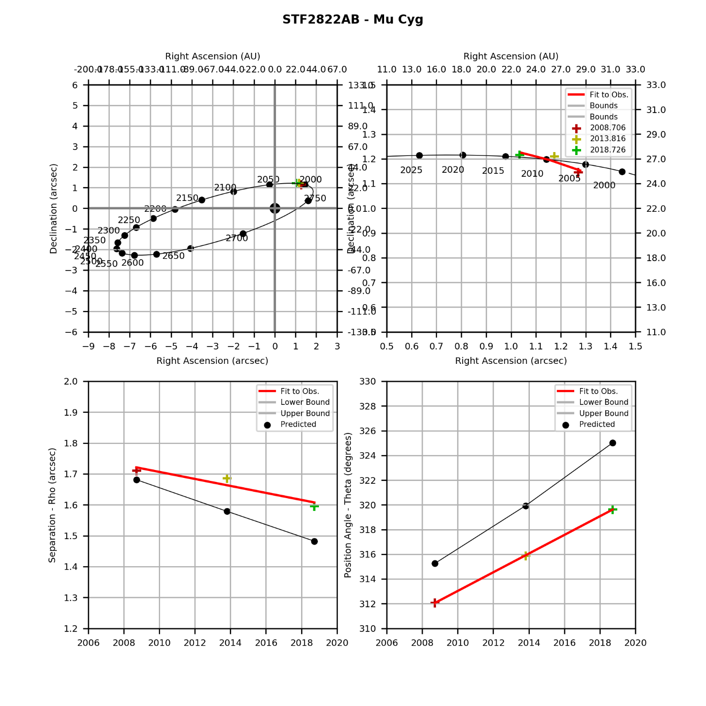

### Lambda Cyngi

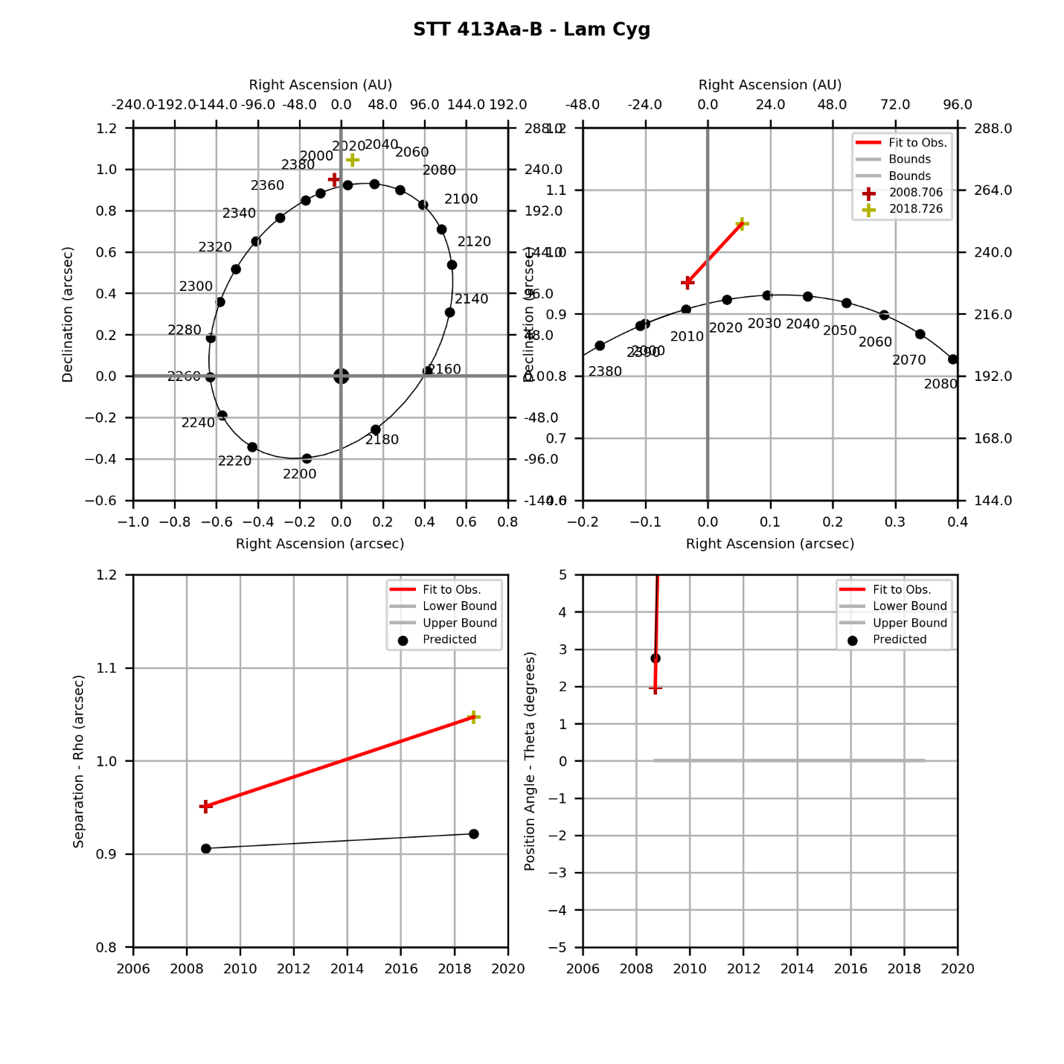

### Delta Cygni

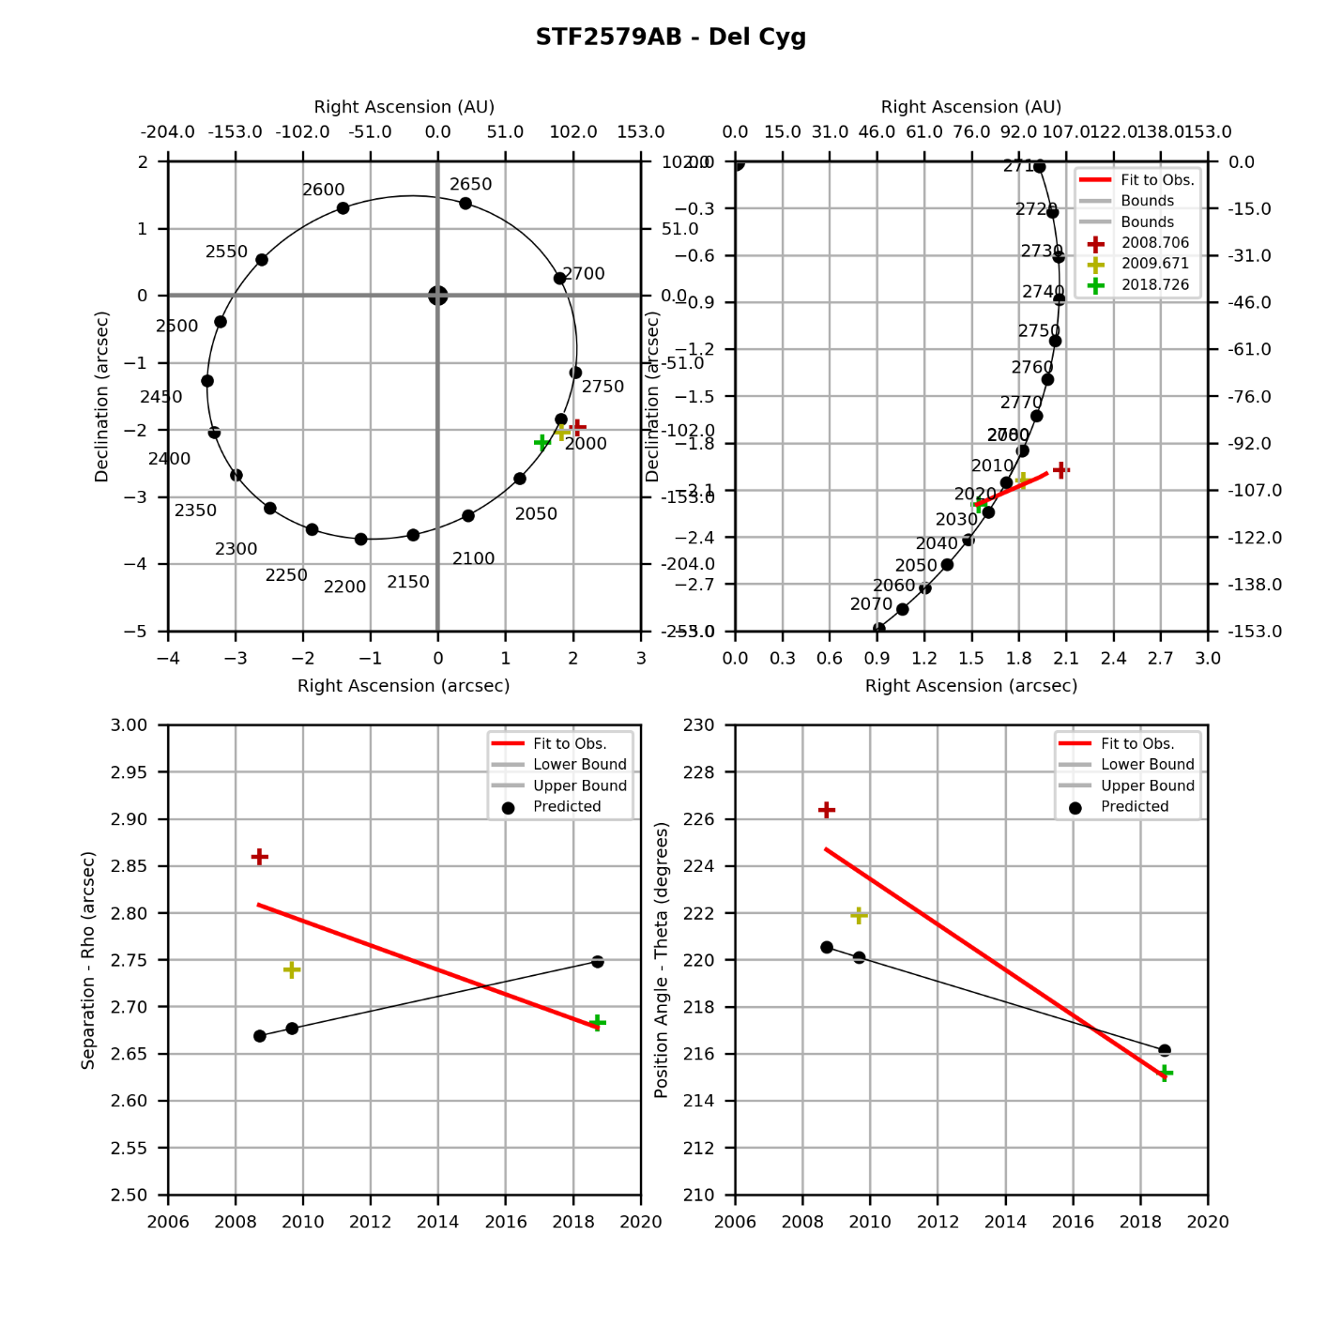

### Beta Cygni

|  |  |  |  |  |  |  |  |  |  |  |  |  |  |  |  |  |  |  |  |  |  |  |  |  |  |  |  |  |  |
| --- | --- | --- | --- | --- | --- | --- | --- | --- | --- | --- | --- | --- | --- | --- | --- | --- | --- | --- | --- | --- | --- | --- | --- | --- | --- | --- | --- | --- | --- |
|  | |  |  |  |  | | --- | --- | --- | --- | | **Parameter** | **Value** | **Rate** | **Units** | | PA(O) |  |  | deg(/yr) | | PA(P) |  |  | deg(/yr) | | PA (O-P) |  |  | deg(/yr) | | Sep(O) |  |  | asec(/yr) | | Sep(P) |  |  | asec(/yr) | | Sep (O-P) |  |  | asec(/yr) | |

### 61 Cygni

|  |  |  |  |  |  |  |  |  |  |  |  |  |  |  |  |  |  |  |  |  |  |  |  |  |  |  |  |  |  |
| --- | --- | --- | --- | --- | --- | --- | --- | --- | --- | --- | --- | --- | --- | --- | --- | --- | --- | --- | --- | --- | --- | --- | --- | --- | --- | --- | --- | --- | --- |
|  | |  |  |  |  | | --- | --- | --- | --- | | **Parameter** | **Value** | **Rate** | **Units** | | PA(O) |  |  | deg(/yr) | | PA(P) |  |  | deg(/yr) | | PA (O-P) |  |  | deg(/yr) | | Sep(O) |  |  | asec(/yr) | | Sep(P) |  |  | asec(/yr) | | Sep (O-P) |  |  | asec(/yr) | |

## Serpens Double Stars

|  |  |  |  |  |
| --- | --- | --- | --- | --- |
| **Star** | **First Obs Date** | **Last Obs Dates** | **N Obs** | **Notes** |
| Del Ser | 2009.512 | 2009.512 | 1 | Has swept through 0 degrees of PA. |

### Del Ser

|  |  |  |  |  |  |  |  |  |  |  |  |  |  |  |  |  |  |  |  |  |  |  |  |  |  |  |  |  |  |
| --- | --- | --- | --- | --- | --- | --- | --- | --- | --- | --- | --- | --- | --- | --- | --- | --- | --- | --- | --- | --- | --- | --- | --- | --- | --- | --- | --- | --- | --- |
|  | |  |  |  |  | | --- | --- | --- | --- | | **Parameter** | **Value** | **Rate** | **Units** | | PA(O) |  |  | deg(/yr) | | PA(P) |  |  | deg(/yr) | | PA (O-P) |  |  | deg(/yr) | | Sep(O) |  |  | asec(/yr) | | Sep(P) |  |  | asec(/yr) | | Sep (O-P) |  |  | asec(/yr) | |

## Draco Double Stars

|  |  |  |  |  |
| --- | --- | --- | --- | --- |
| **Star** | **First Obs Date** | **Last Obs Dates** | **N Obs** | **Notes** |
| Mu Dra | 2007.714 | 2013.816 | 7 | Has swept through TBD degrees of PA. |
| 17 Dra | 2011.693 | 2017.775 | 2 | Fixed double |
| 17 Dra AC | 2011.693 | 2011.693 | 1 | Fixed double |
| 17 Dra CD | 2011.693 | 2011.693 | 1 | Fixed double |
| Om Dra | 2011.676 | 2011.676 | 1 | Fixed double |
| Nu Dra | 2011.676 | 2011.676 | 1 | Fixed double |

### Mu Dra

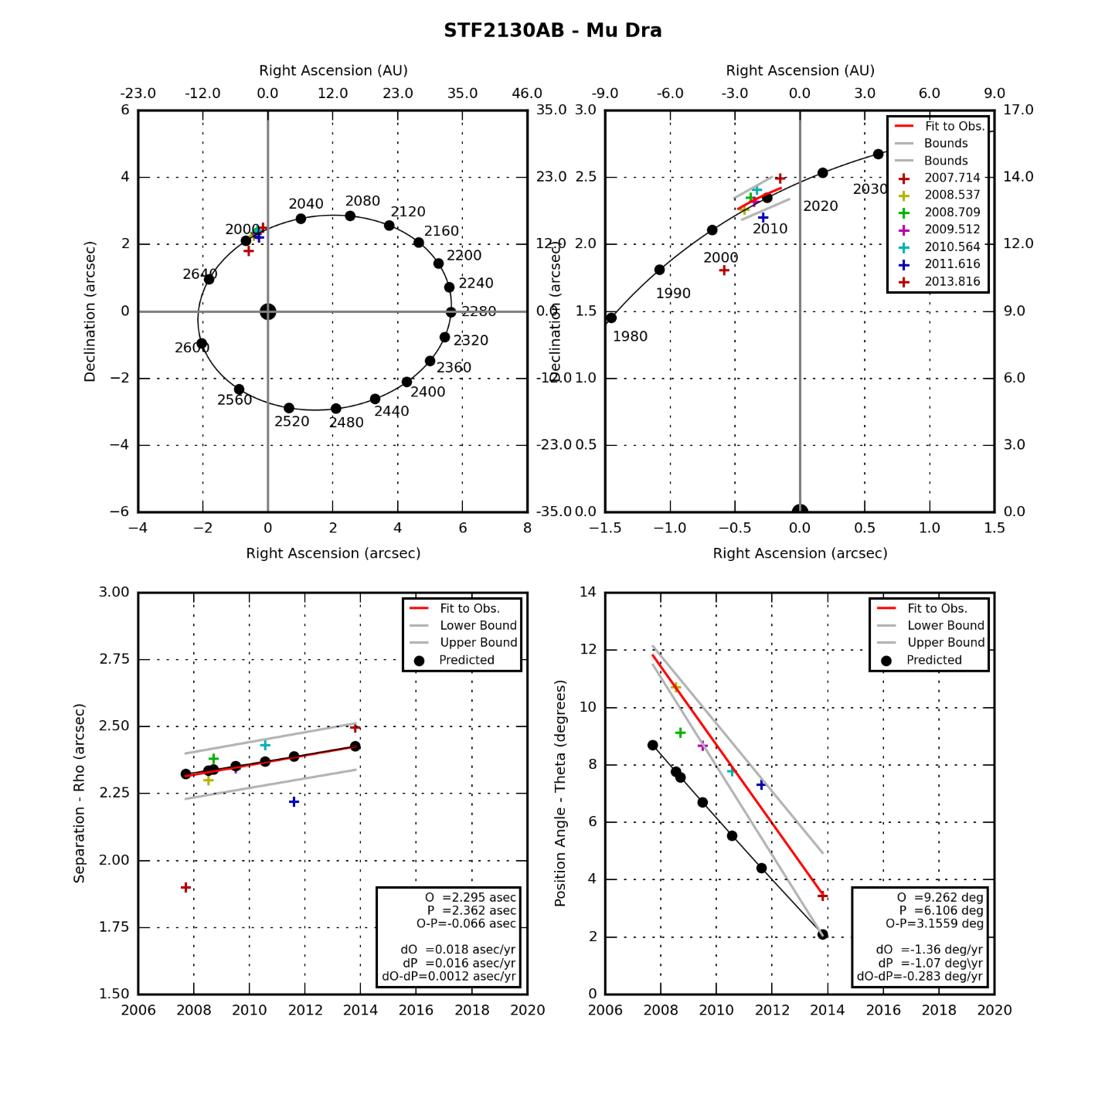

### 17 Draconis

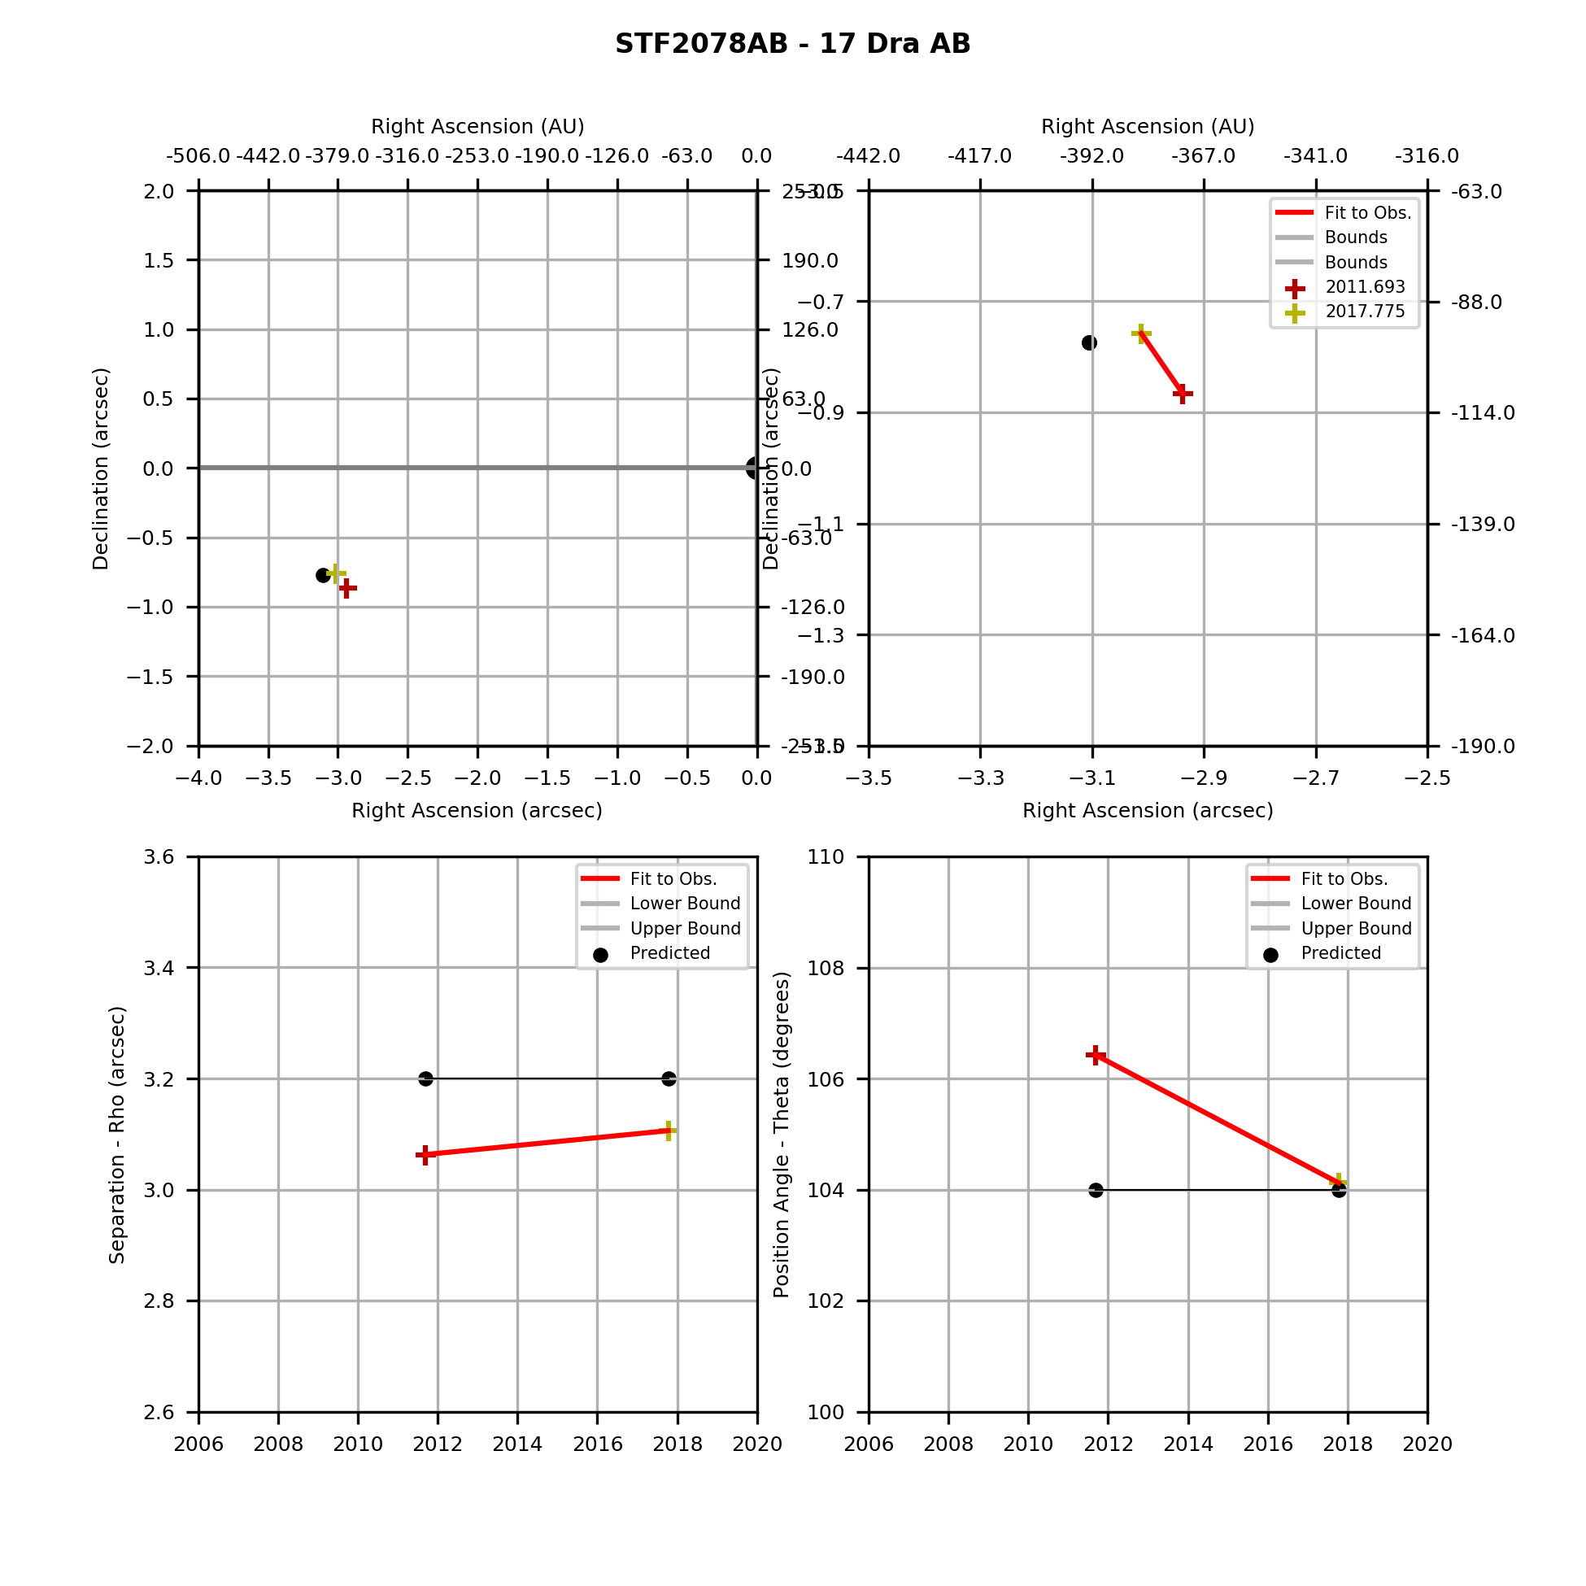

### 17 Dra AC

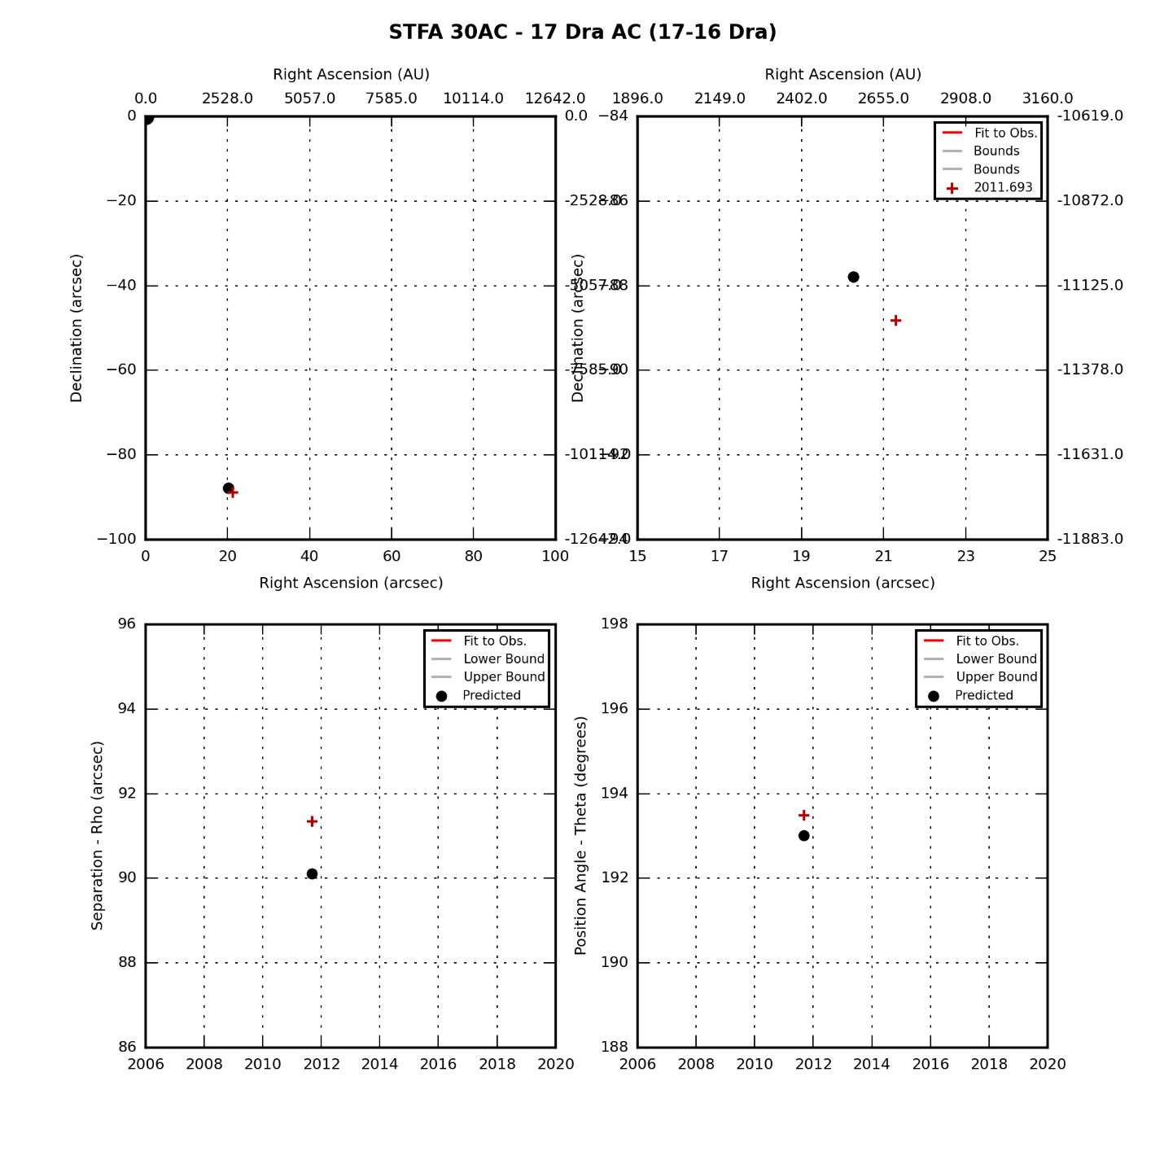

### 17 Dra CD

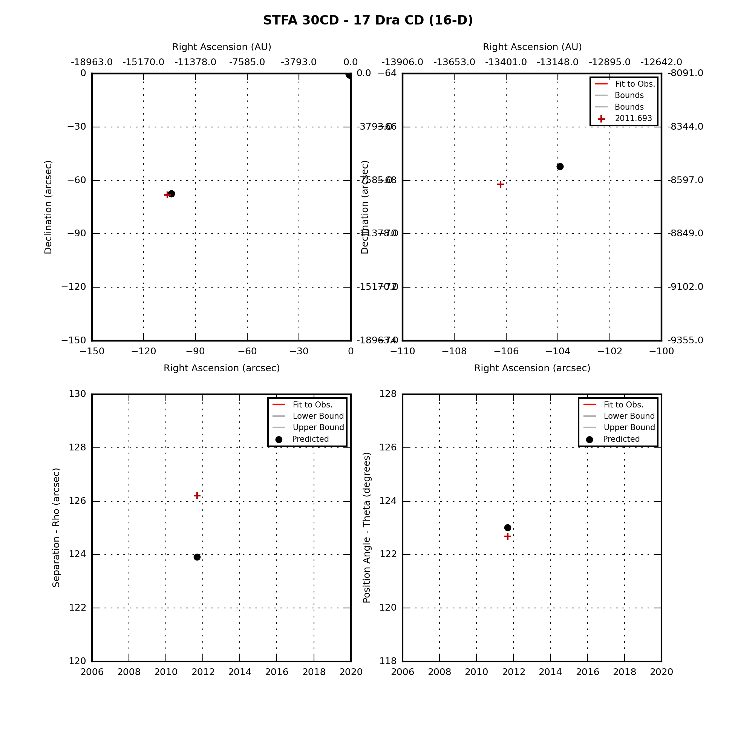

### Omicron Draconis

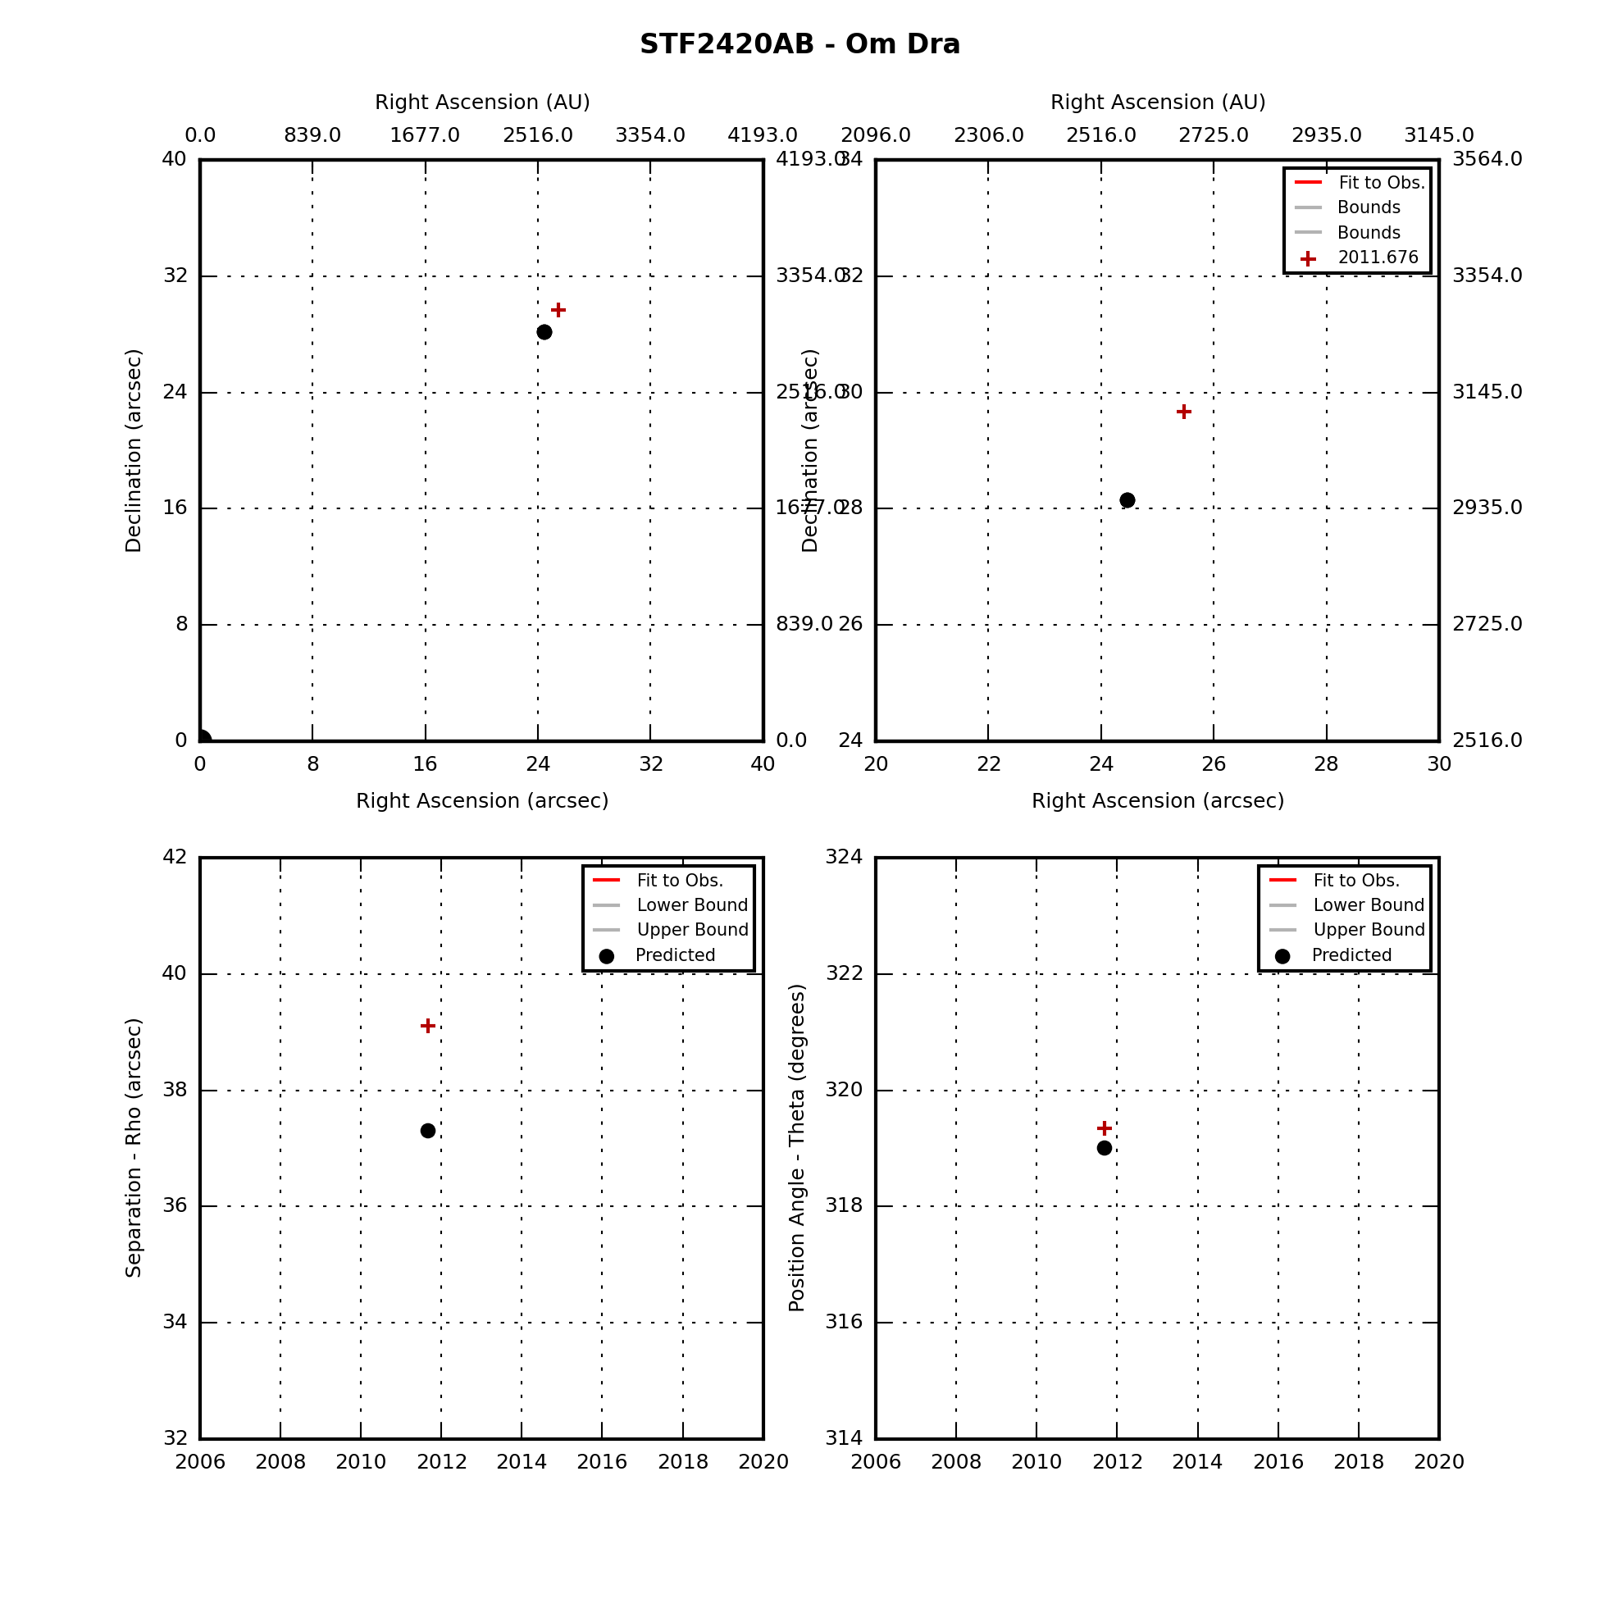

### Nu Draconis

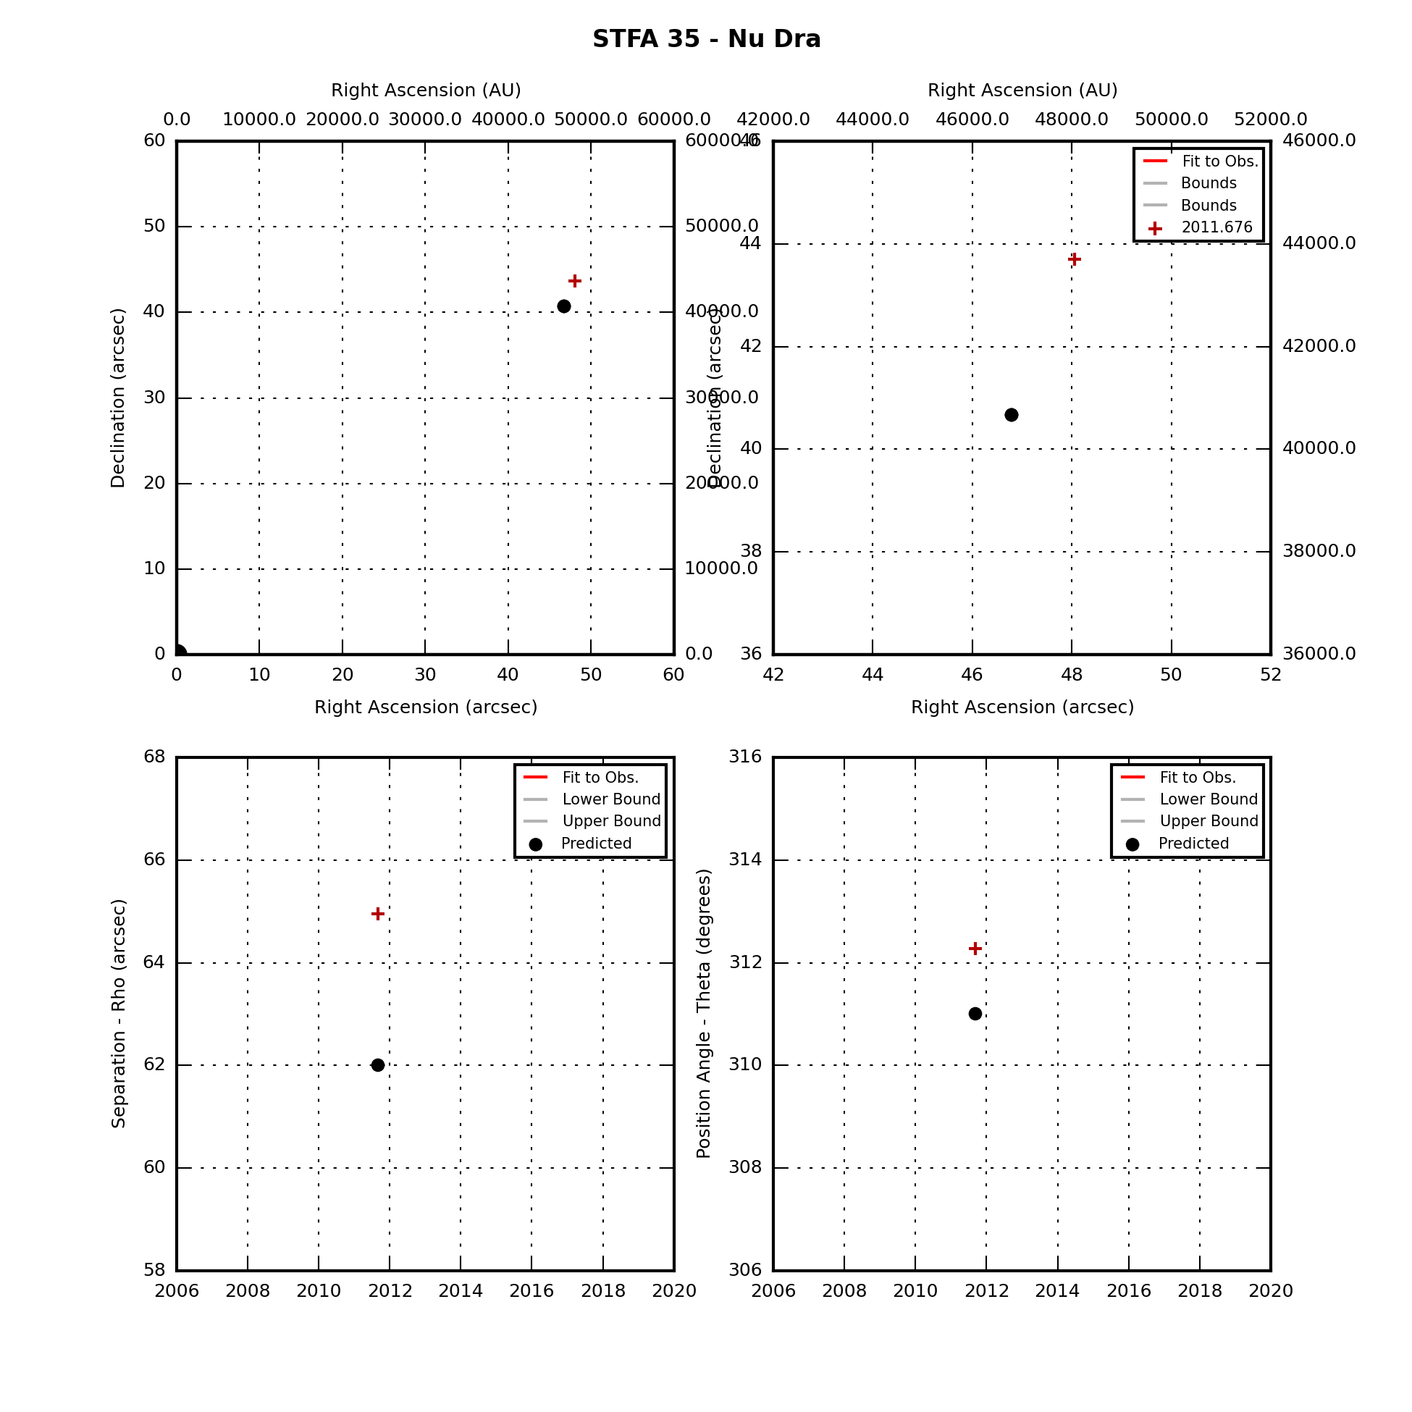

## Cassiopeia Double Stars

|  |  |  |  |  |
| --- | --- | --- | --- | --- |
| **Star** | **First Obs Date** | **Last Obs Dates** | **N Obs** | **Notes** |
| Eta Cas | 1994.961 | 2013.816 | 5 | Has swept through TBD degrees of PA. |
| STF 3062 | 2010.082 | 2011.079 | 2 | Has swept through TBD degrees of PA. |
| Iot Cas Aa-B | 2009.082 | 2010.082 | 2 | Has swept through TBD degrees of PA. |
| Iot Cas A-C | 2009.082 | 2010.082 | 2 | Fixed double |

### Eta Cass

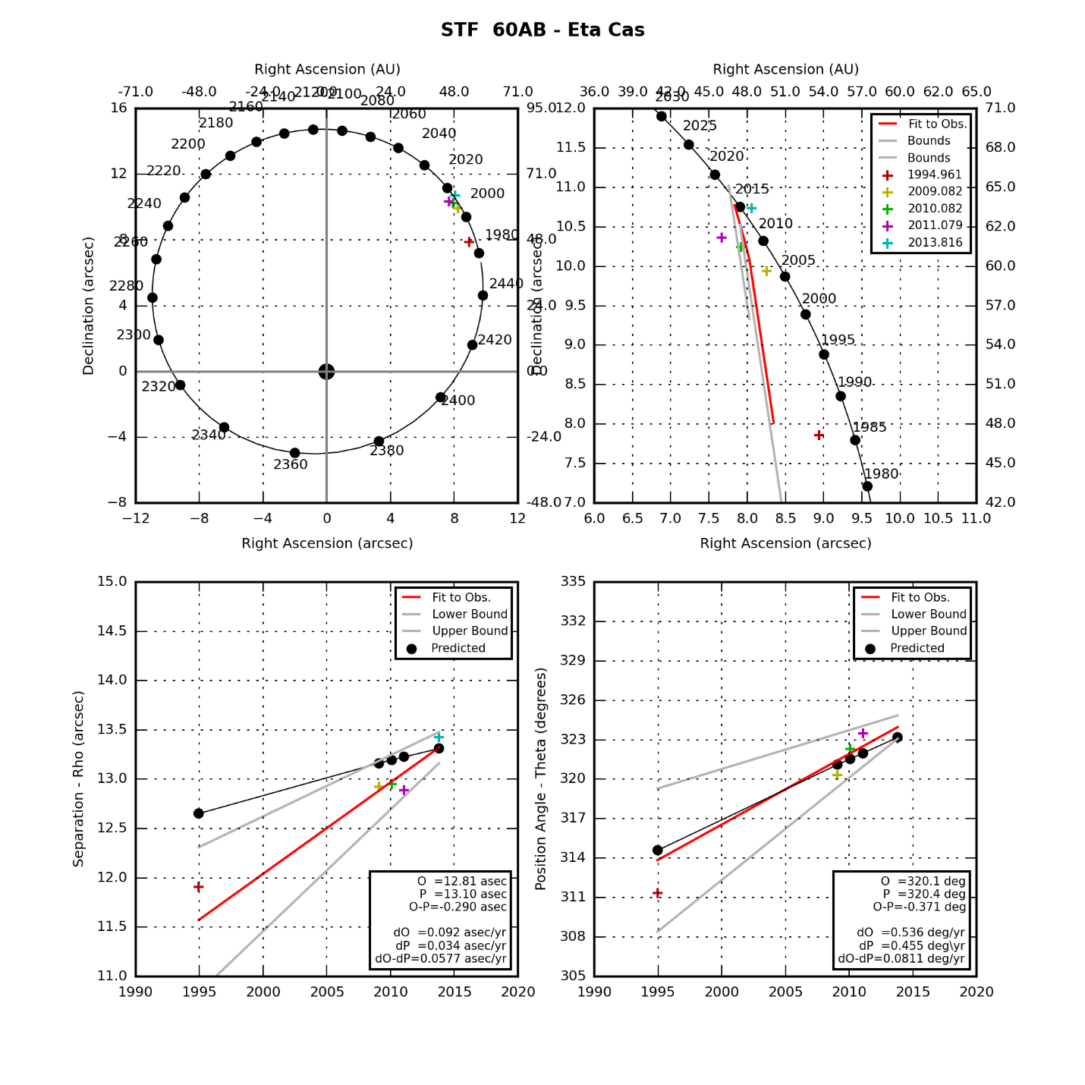

### STF 3062

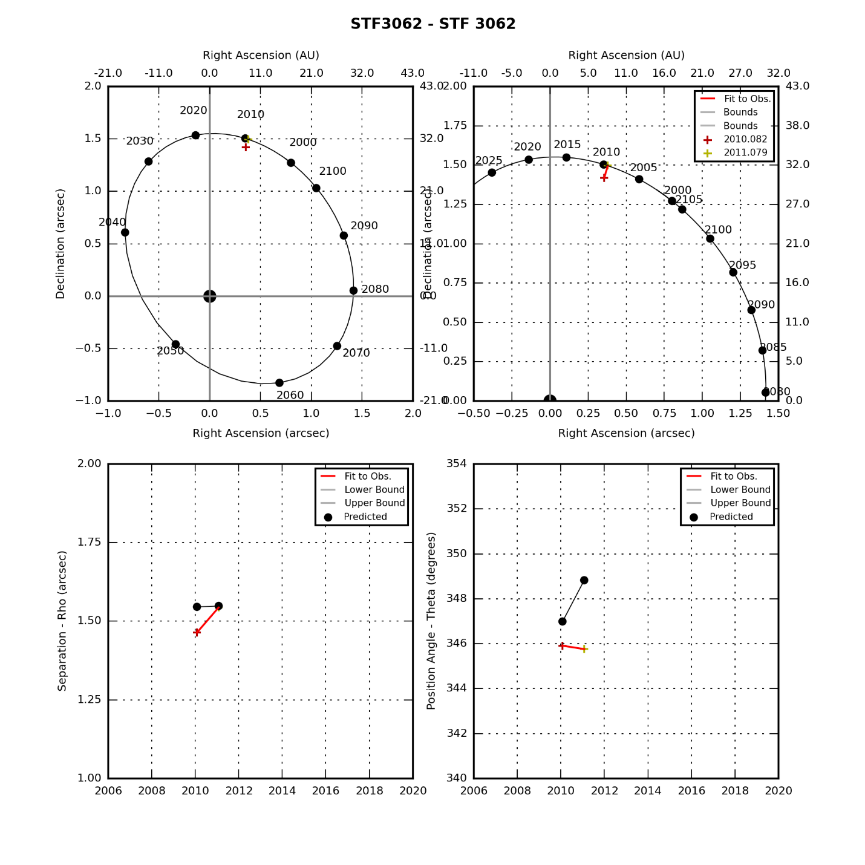

### Iot Cassiopeia Aa-B

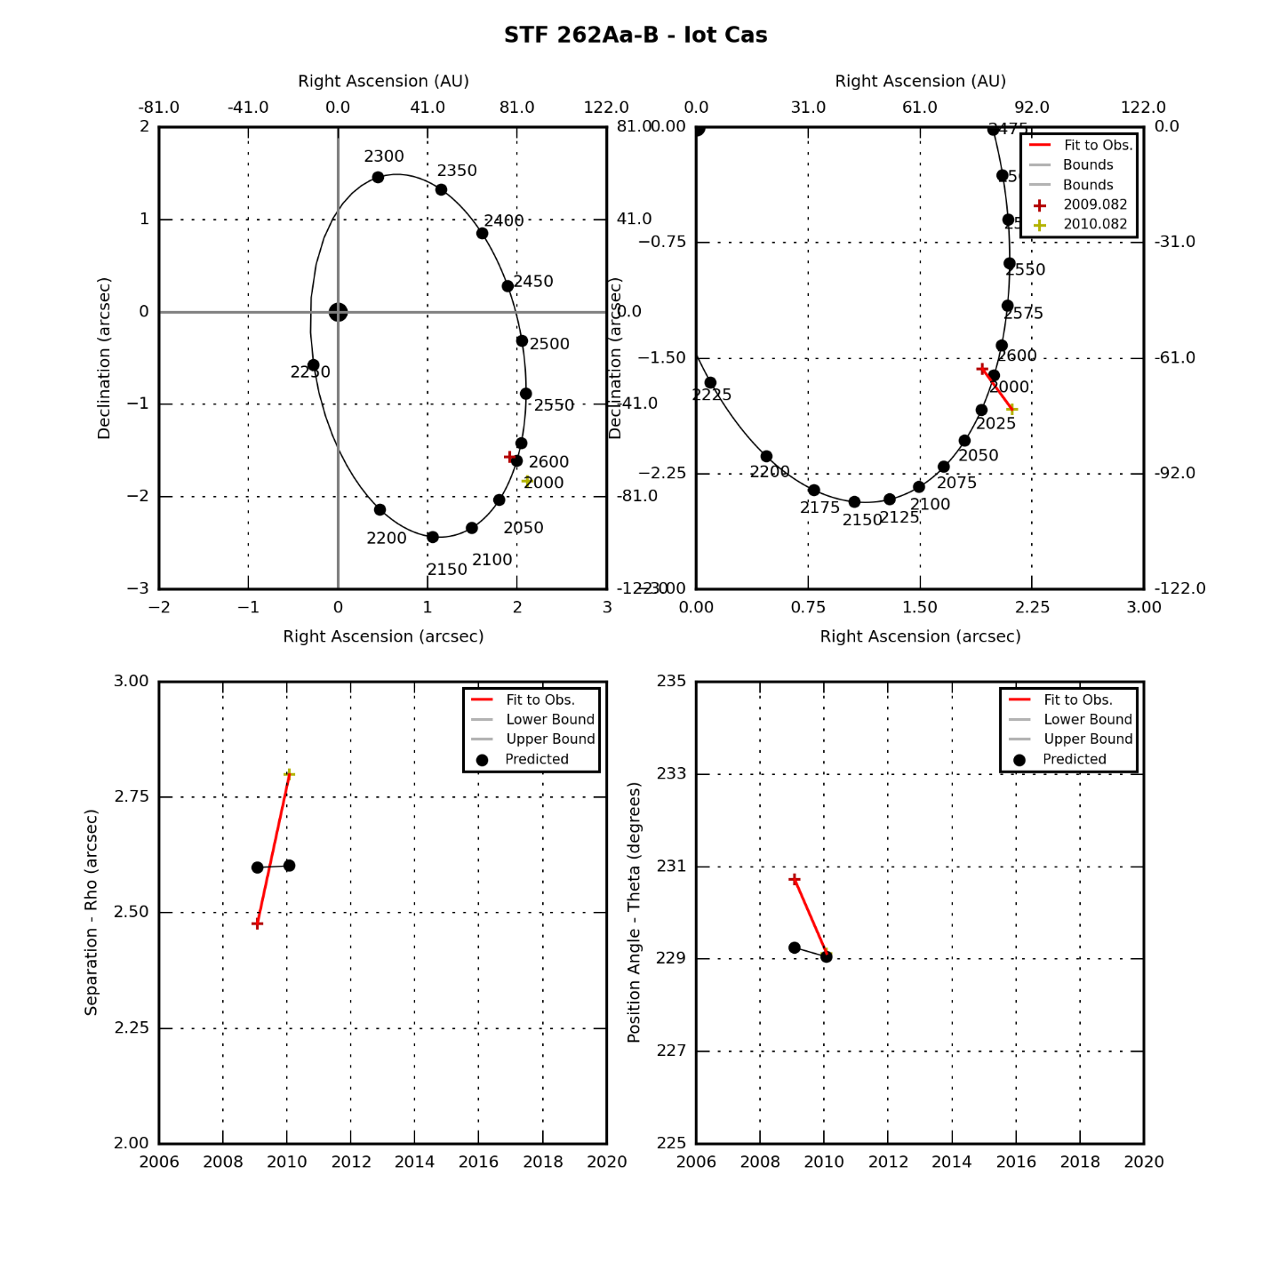

### Iot Cass A-C

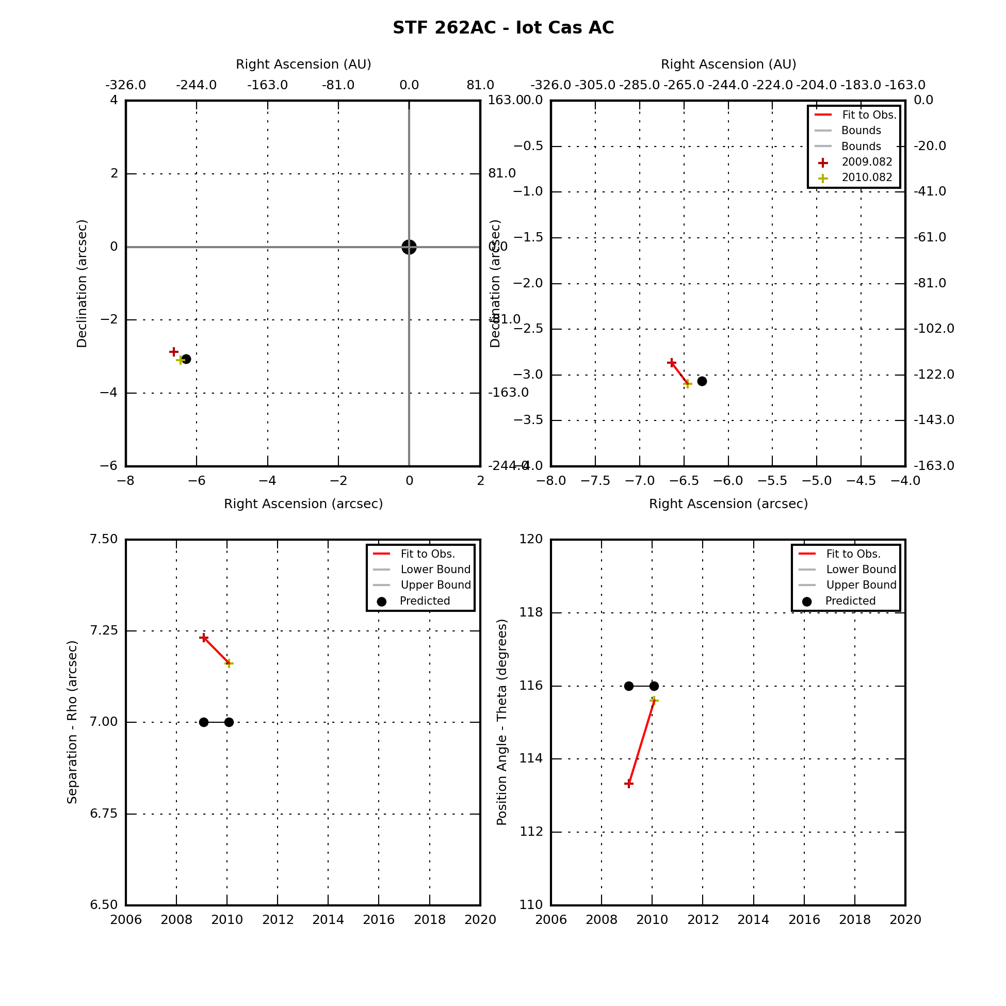

## Andromeda Double Stars

|  |  |  |  |  |
| --- | --- | --- | --- | --- |
| **Star** | **First Obs Date** | **Last Obs Dates** | **N Obs** | **Notes** |
| Gam And | 2009.082 | 2009.082 | 1 | Fixed double |

### Gam And

|  |  |  |  |  |  |  |  |  |  |  |  |  |  |  |  |  |  |  |  |  |  |  |  |  |  |  |  |  |  |
| --- | --- | --- | --- | --- | --- | --- | --- | --- | --- | --- | --- | --- | --- | --- | --- | --- | --- | --- | --- | --- | --- | --- | --- | --- | --- | --- | --- | --- | --- |
|  | |  |  |  |  | | --- | --- | --- | --- | | **Parameter** | **Value** | **Rate** | **Units** | | PA(O) |  |  | deg(/yr) | | PA(P) |  |  | deg(/yr) | | PA (O-P) |  |  | deg(/yr) | | Sep(O) |  |  | asec(/yr) | | Sep(P) |  |  | asec(/yr) | | Sep (O-P) |  |  | asec(/yr) | |

## Lynx Double Stars

|  |  |  |  |  |
| --- | --- | --- | --- | --- |
| **Star** | **First Obs Date** | **Last Obs Dates** | **N Obs** | **Notes** |
| 12 Lyn | 2009.197 | 2010.200 | 2 | Has swept through TBD degrees of PA. |

### 12 Lynx

|  |  |  |  |  |  |  |  |  |  |  |  |  |  |  |  |  |  |  |  |  |  |  |  |  |  |  |  |  |  |
| --- | --- | --- | --- | --- | --- | --- | --- | --- | --- | --- | --- | --- | --- | --- | --- | --- | --- | --- | --- | --- | --- | --- | --- | --- | --- | --- | --- | --- | --- |
|  | |  |  |  |  | | --- | --- | --- | --- | | **Parameter** | **Value** | **Rate** | **Units** | | PA(O) |  |  | deg(/yr) | | PA(P) |  |  | deg(/yr) | | PA (O-P) |  |  | deg(/yr) | | Sep(O) |  |  | asec(/yr) | | Sep(P) |  |  | asec(/yr) | | Sep (O-P) |  |  | asec(/yr) | |

|  |  |  |  |  |  |  |  |  |  |  |  |  |  |  |  |  |  |  |  |  |  |  |  |  |  |  |  |  |  |
| --- | --- | --- | --- | --- | --- | --- | --- | --- | --- | --- | --- | --- | --- | --- | --- | --- | --- | --- | --- | --- | --- | --- | --- | --- | --- | --- | --- | --- | --- |
|  | |  |  |  |  | | --- | --- | --- | --- | | **Parameter** | **Value** | **Rate** | **Units** | | PA(O) |  |  | deg(/yr) | | PA(P) |  |  | deg(/yr) | | PA (O-P) |  |  | deg(/yr) | | Sep(O) |  |  | asec(/yr) | | Sep(P) |  |  | asec(/yr) | | Sep (O-P) |  |  | asec(/yr) | |

## Orion Double Stars

|  |  |  |  |  |
| --- | --- | --- | --- | --- |
| **Star** | **First Obs Date** | **Last Obs Dates** | **N Obs** | **Notes** |
| 32 Ori | 2008.082 | 2009.197 | 2 | Has swept through TBD degrees of PA. |
| Eta Ori | 2008.137 | 2009.197 | 3 | Fixed double |
| Alnitak | 2008.137 | 2009.197 | 2 | Has swept through TBD degrees of PA. |
| Rigel | 2007.975 | 2009.197 | 3 | Fixed double |

### 32 Orionis

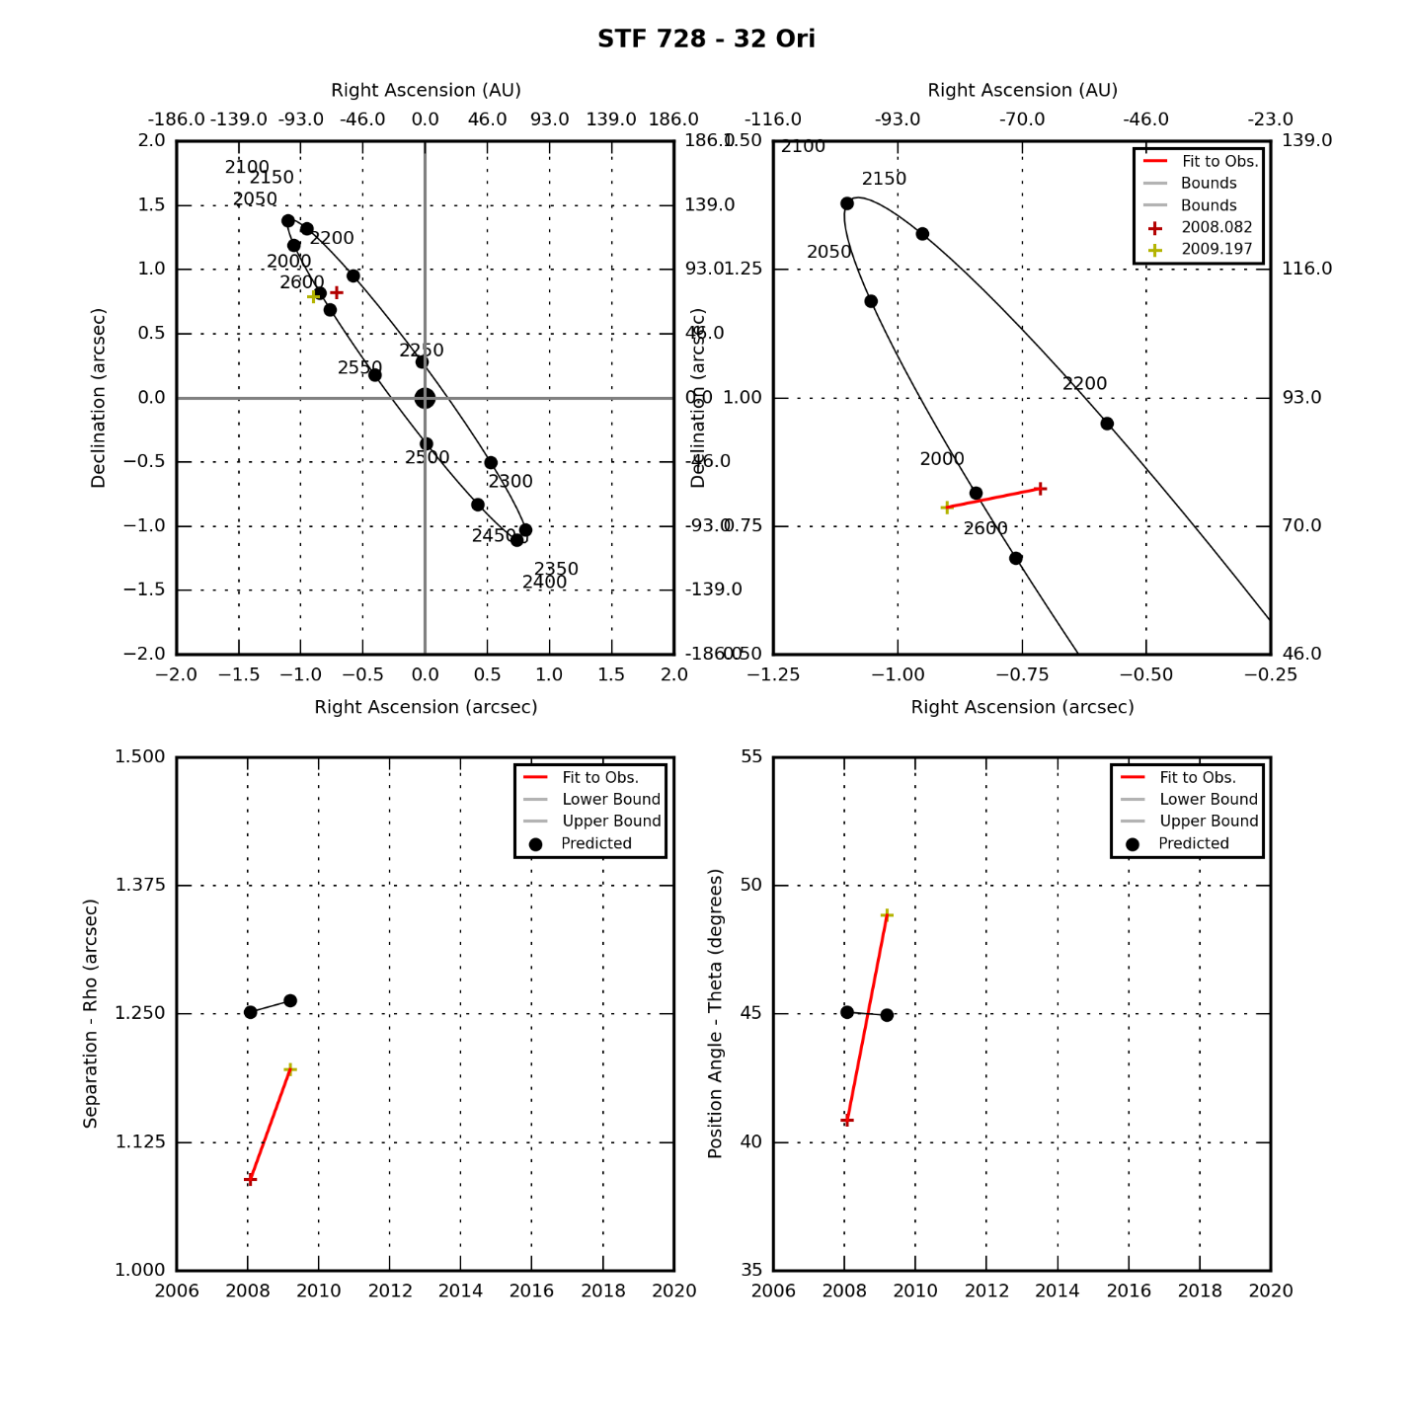

### Eta Orionis

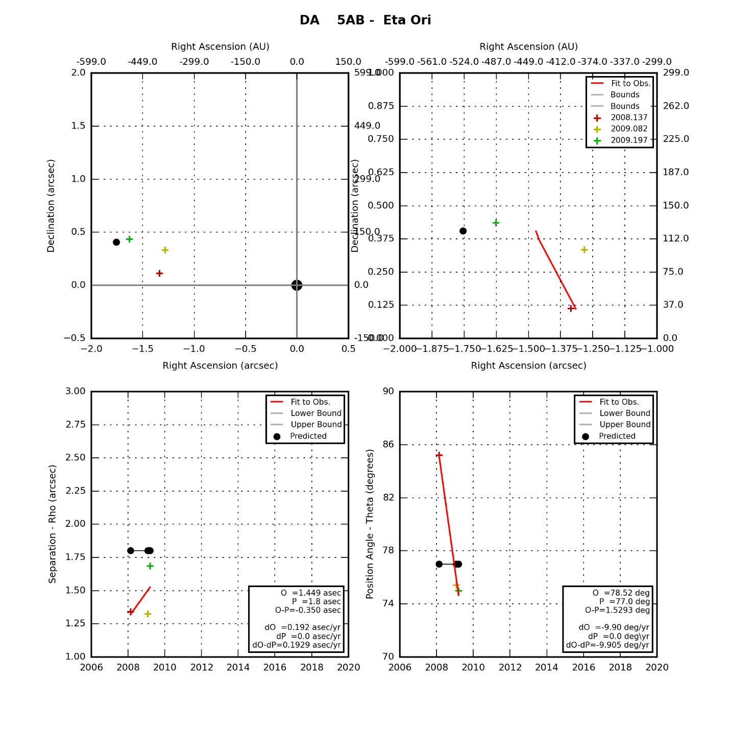

### Alnitak

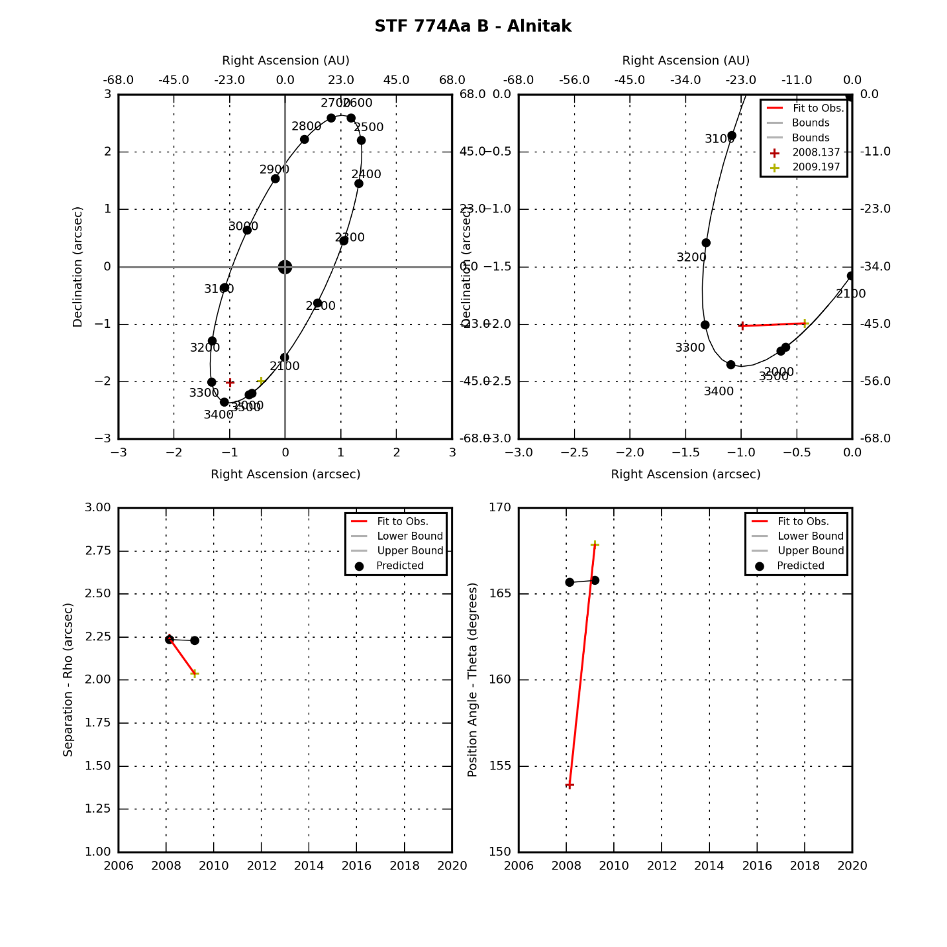

### Rigel

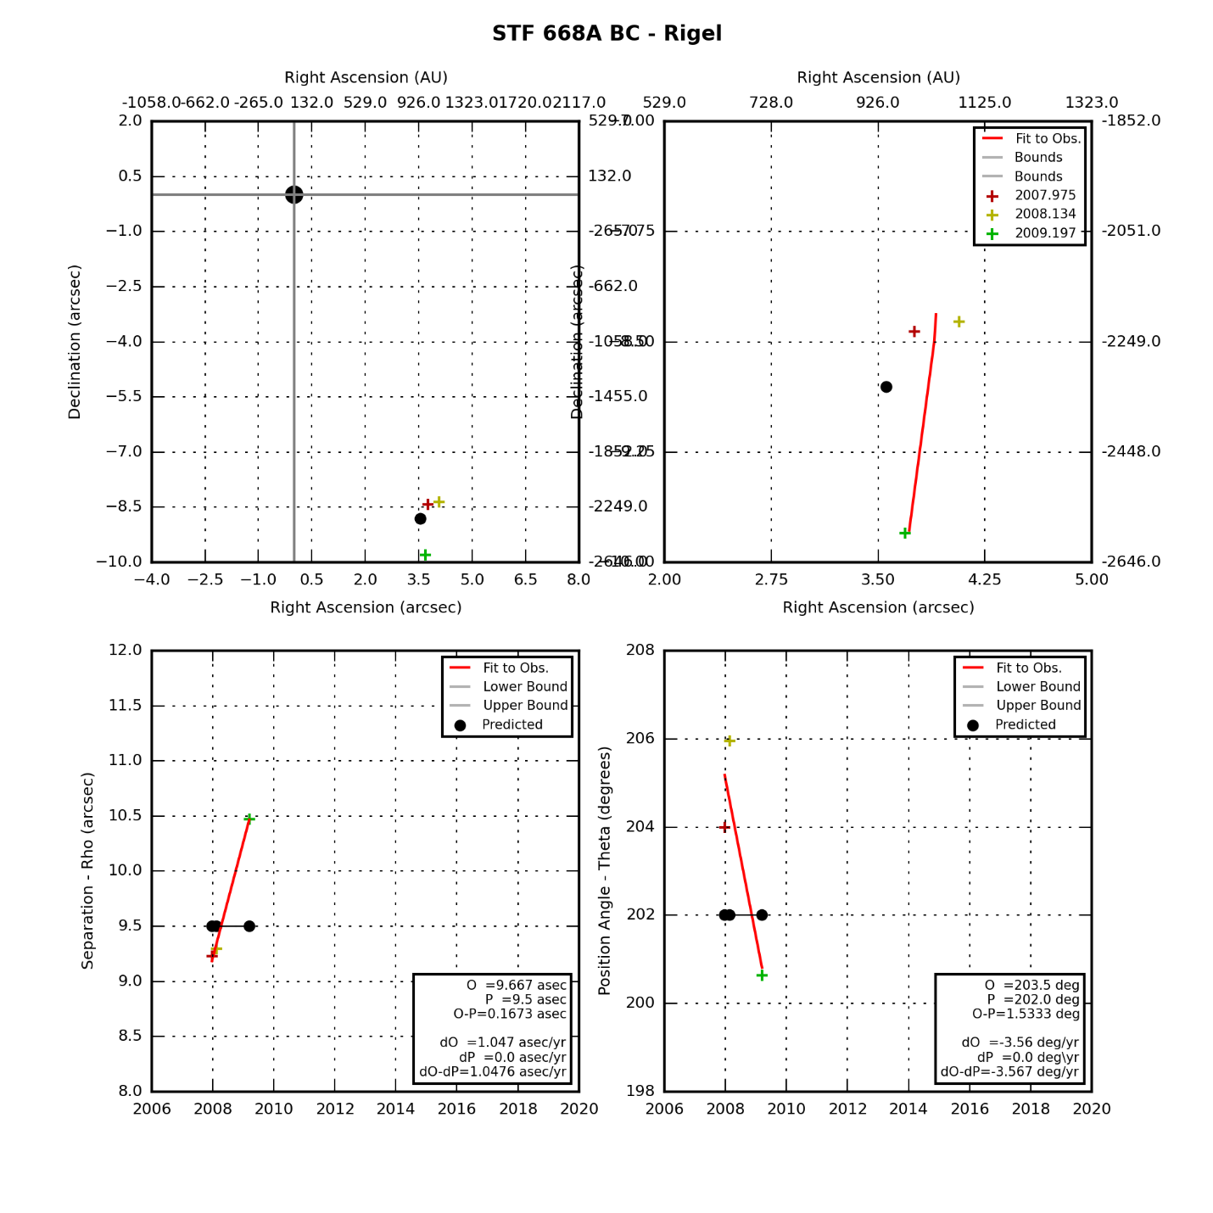

## Gemini Double Stars

|  |  |  |  |  |
| --- | --- | --- | --- | --- |
| **Star** | **First Obs Date** | **Last Obs Dates** | **N Obs** | **Notes** |
| Castor | 2008.137 | 2013.246 | 10 | Has swept through TBD degrees of PA. |
| YY Gem | 2013.175 | 2013.246 | 3 | No orbit determined |
| 38 Gem | 2009.079 | 2011.079 | 3 | Fixed double |
| Eta Gem | 2009.197 | 2011.079 | 3 | Has swept through TBD degrees of PA. |
| Del Gem | 2009.197 | 2009.197 | 1 | Has swept through 0 degrees of PA. |

### Castor

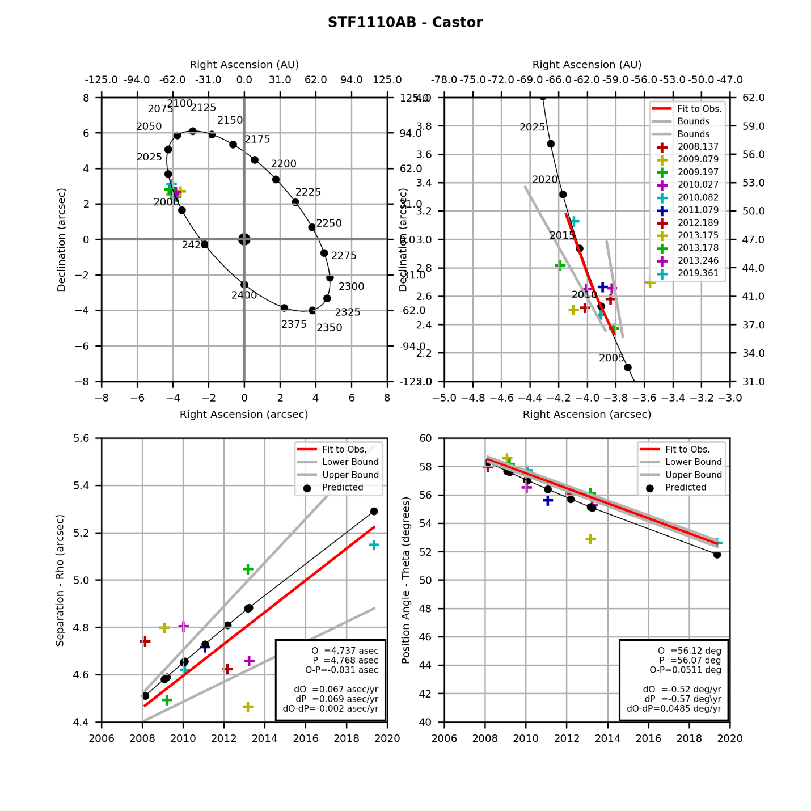

### YY Gem

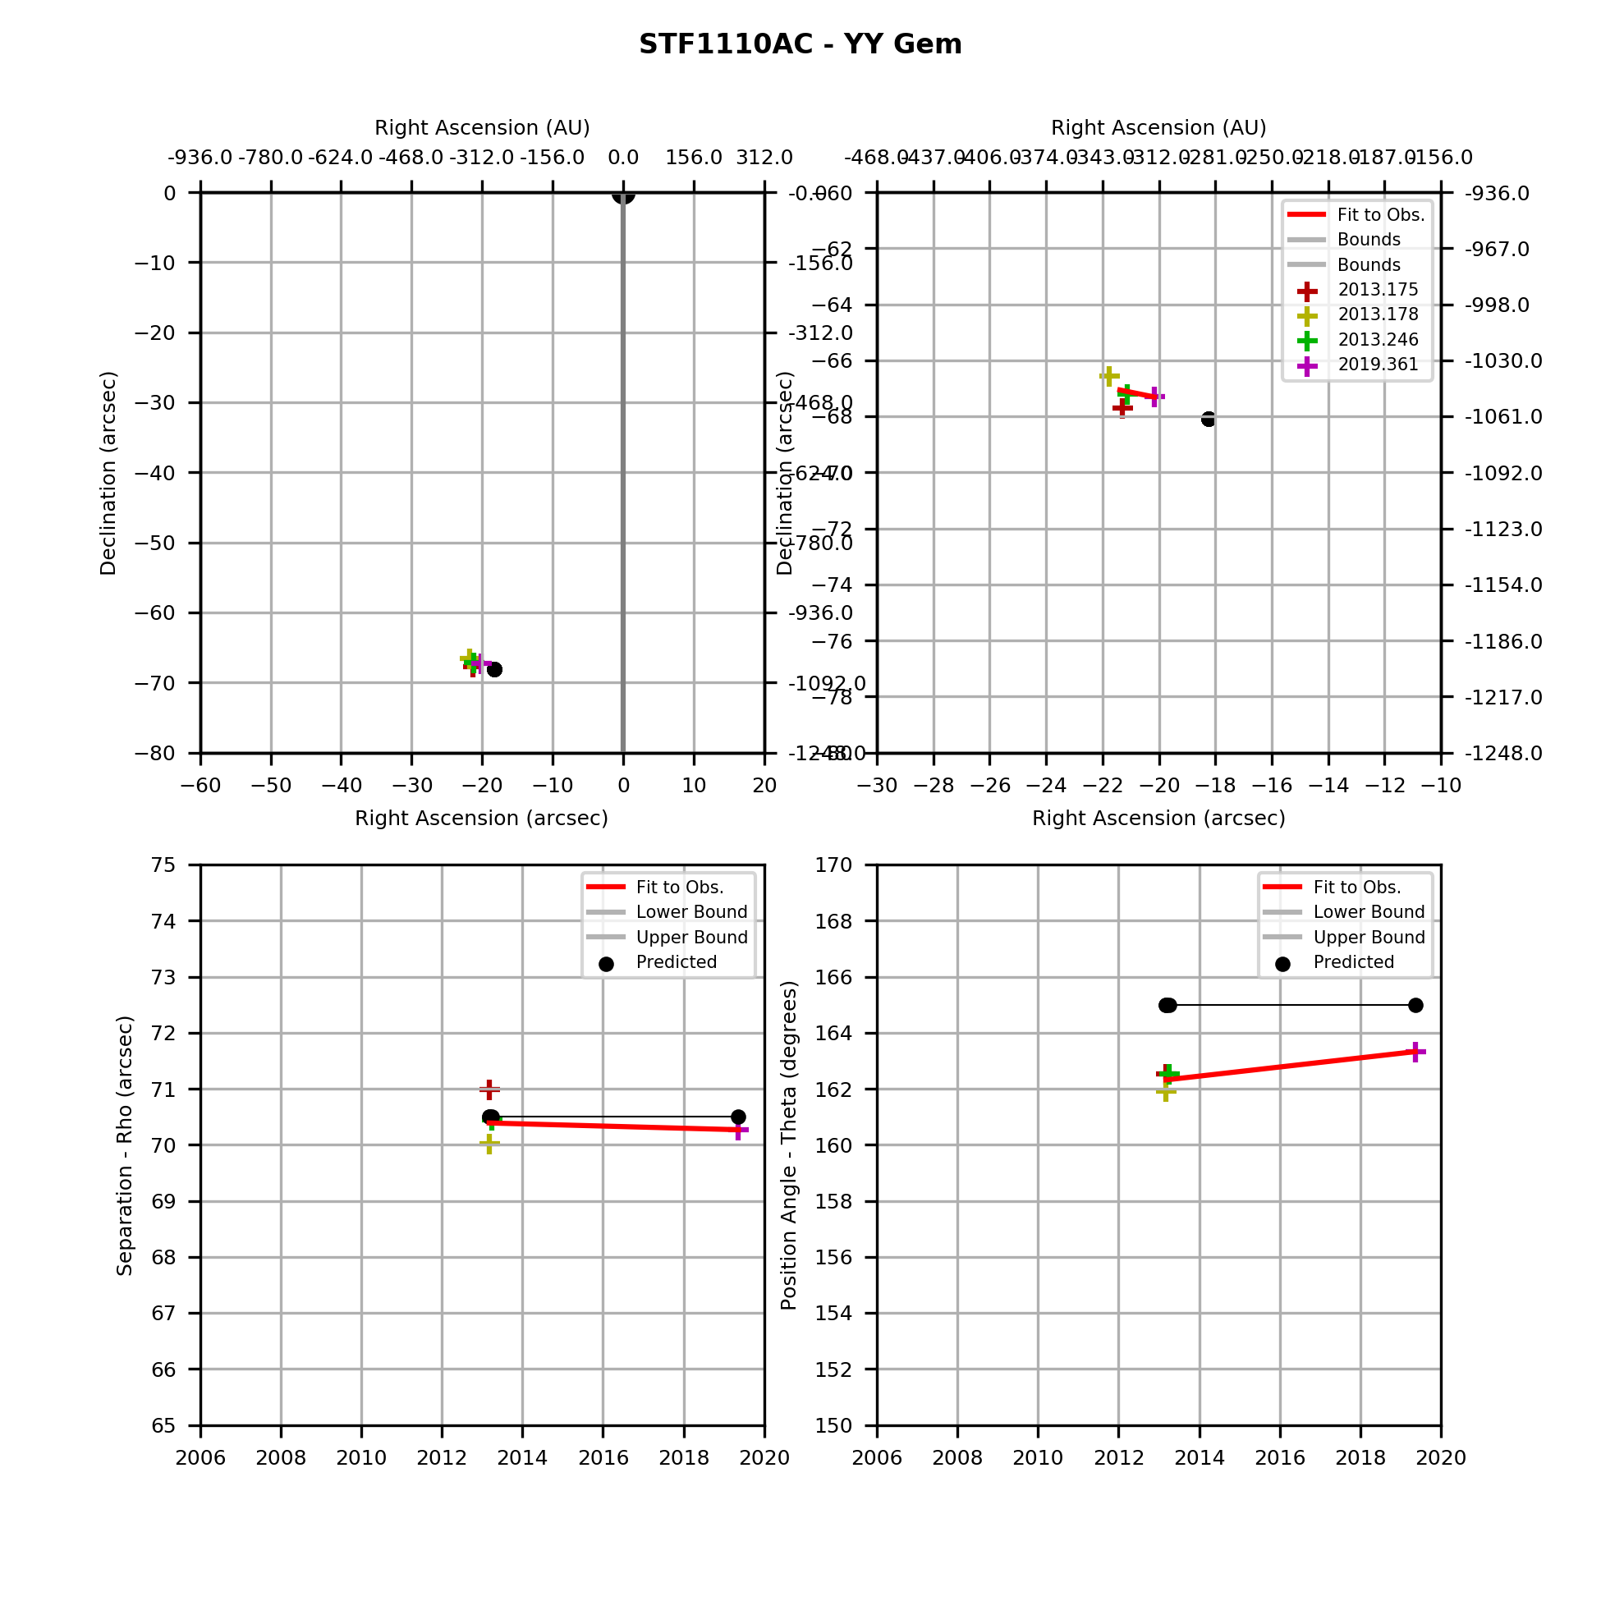

### 38 Gem

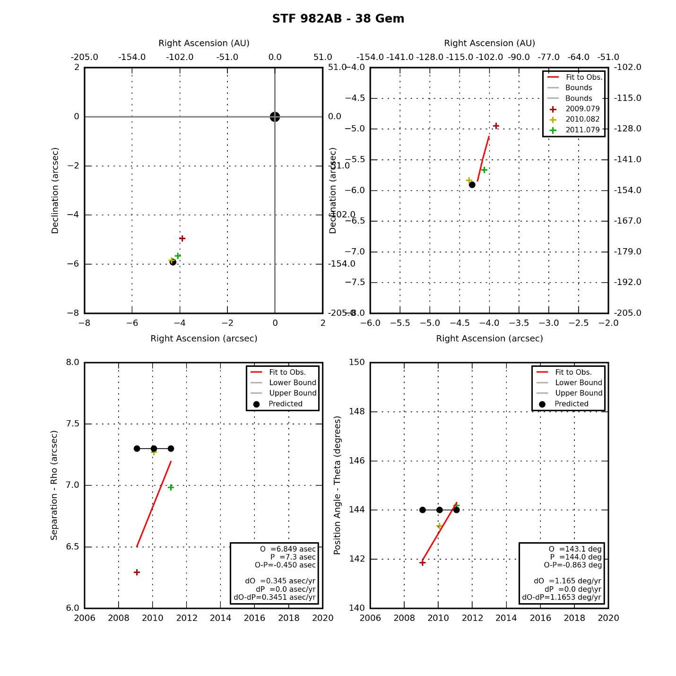

### Eta Gem

|  |  |  |  |  |  |  |  |  |  |  |  |  |  |  |  |  |  |  |  |  |  |  |  |  |  |  |  |  |  |
| --- | --- | --- | --- | --- | --- | --- | --- | --- | --- | --- | --- | --- | --- | --- | --- | --- | --- | --- | --- | --- | --- | --- | --- | --- | --- | --- | --- | --- | --- |
|  | |  |  |  |  | | --- | --- | --- | --- | | **Parameter** | **Value** | **Rate** | **Units** | | PA(O) |  |  | deg(/yr) | | PA(P) |  |  | deg(/yr) | | PA (O-P) |  |  | deg(/yr) | | Sep(O) |  |  | asec(/yr) | | Sep(P) |  |  | asec(/yr) | | Sep (O-P) |  |  | asec(/yr) | |

### Del Gem

|  |  |  |  |  |  |  |  |  |  |  |  |  |  |  |  |  |  |  |  |  |  |  |  |  |  |  |  |  |  |
| --- | --- | --- | --- | --- | --- | --- | --- | --- | --- | --- | --- | --- | --- | --- | --- | --- | --- | --- | --- | --- | --- | --- | --- | --- | --- | --- | --- | --- | --- |
|  | |  |  |  |  | | --- | --- | --- | --- | | **Parameter** | **Value** | **Rate** | **Units** | | PA(O) |  |  | deg(/yr) | | PA(P) |  |  | deg(/yr) | | PA (O-P) |  |  | deg(/yr) | | Sep(O) |  |  | asec(/yr) | | Sep(P) |  |  | asec(/yr) | | Sep (O-P) |  |  | asec(/yr) | |

## Canis Major Double Stars

|  |  |  |  |  |
| --- | --- | --- | --- | --- |
| **Star** | **First Obs Date** | **Last Obs Dates** | **N Obs** | **Notes** |
| Sirius |  |  | 0 | No successful detections as of 2019 |

### Sirius

|  |  |  |  |  |  |  |  |  |  |  |  |  |  |  |  |  |  |  |  |  |  |  |  |  |  |  |  |  |  |
| --- | --- | --- | --- | --- | --- | --- | --- | --- | --- | --- | --- | --- | --- | --- | --- | --- | --- | --- | --- | --- | --- | --- | --- | --- | --- | --- | --- | --- | --- |
|  | |  |  |  |  | | --- | --- | --- | --- | | **Parameter** | **Value** | **Rate** | **Units** | | PA(O) |  |  | deg(/yr) | | PA(P) |  |  | deg(/yr) | | PA (O-P) |  |  | deg(/yr) | | Sep(O) |  |  | asec(/yr) | | Sep(P) |  |  | asec(/yr) | | Sep (O-P) |  |  | asec(/yr) | |

## Cancer Double Stars

|  |  |  |  |  |
| --- | --- | --- | --- | --- |
| **Star** | **First Obs Date** | **Last Obs Dates** | **N Obs** | **Notes** |
| Zet Cnc AB | 2009.189 | 2012.189 | 5 | Has swept through TBD degrees of PA. |
| Zet Cnc AB-C | 2009.082 | 2012.189 | 6 | Has swept through TBD degrees of PA. |

### Zet Cnc AB

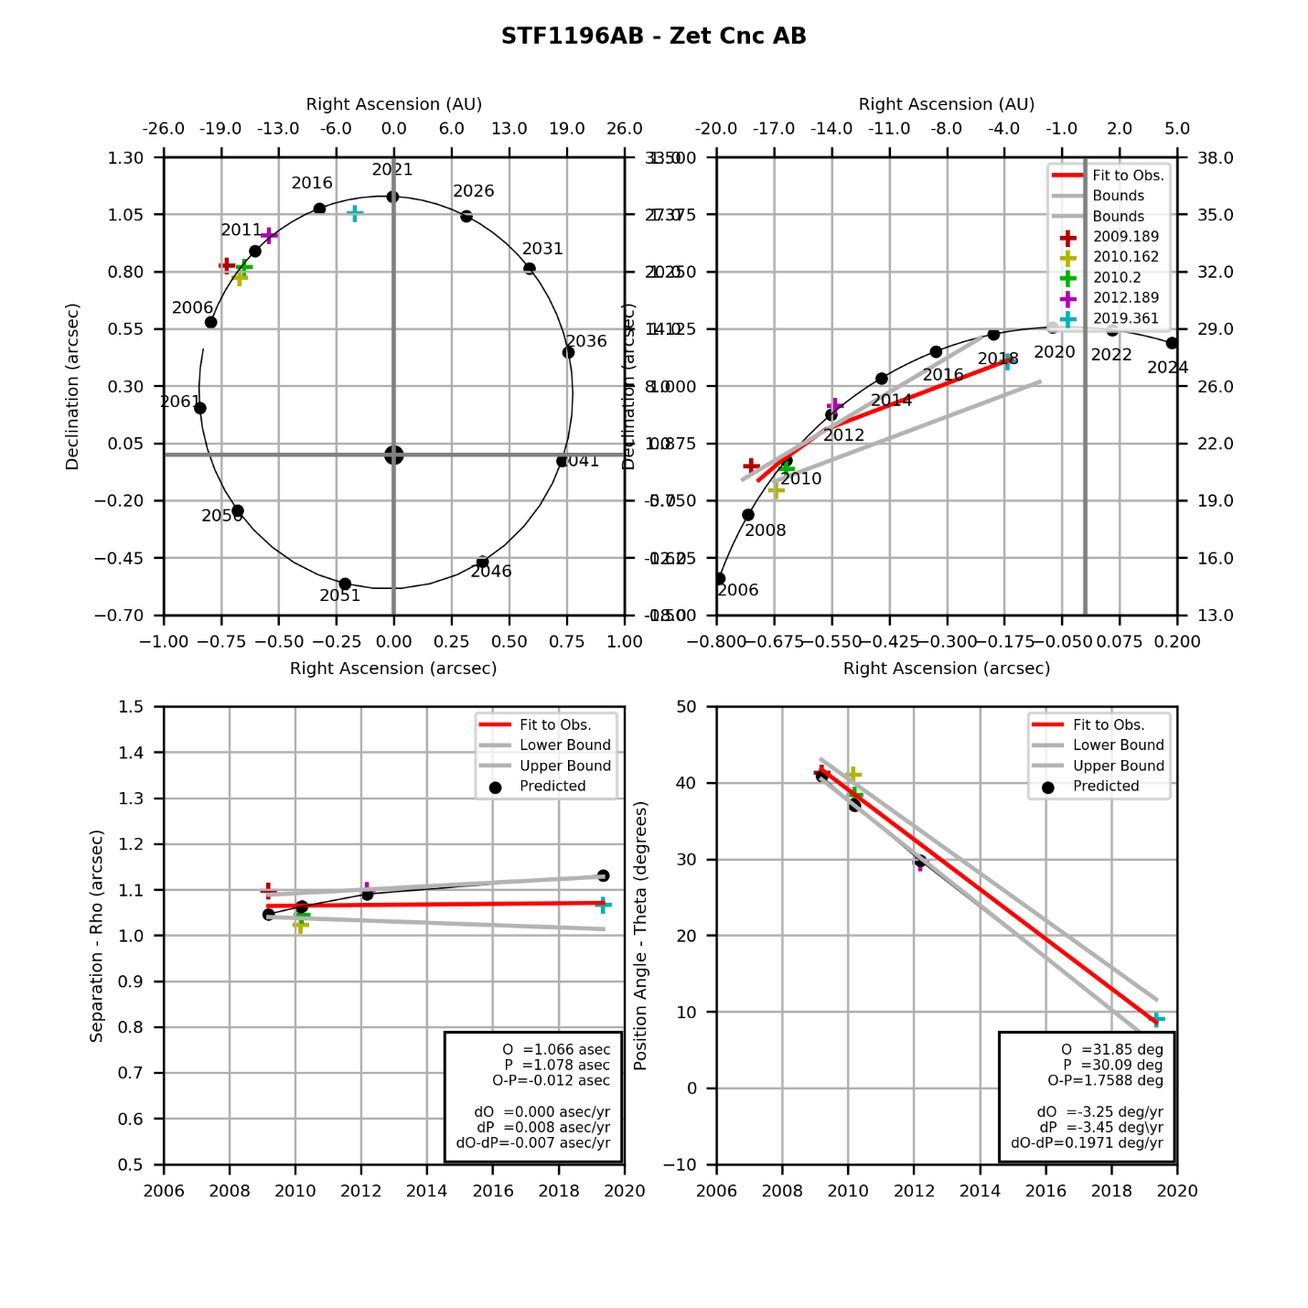

### Zet Cnc AB-C

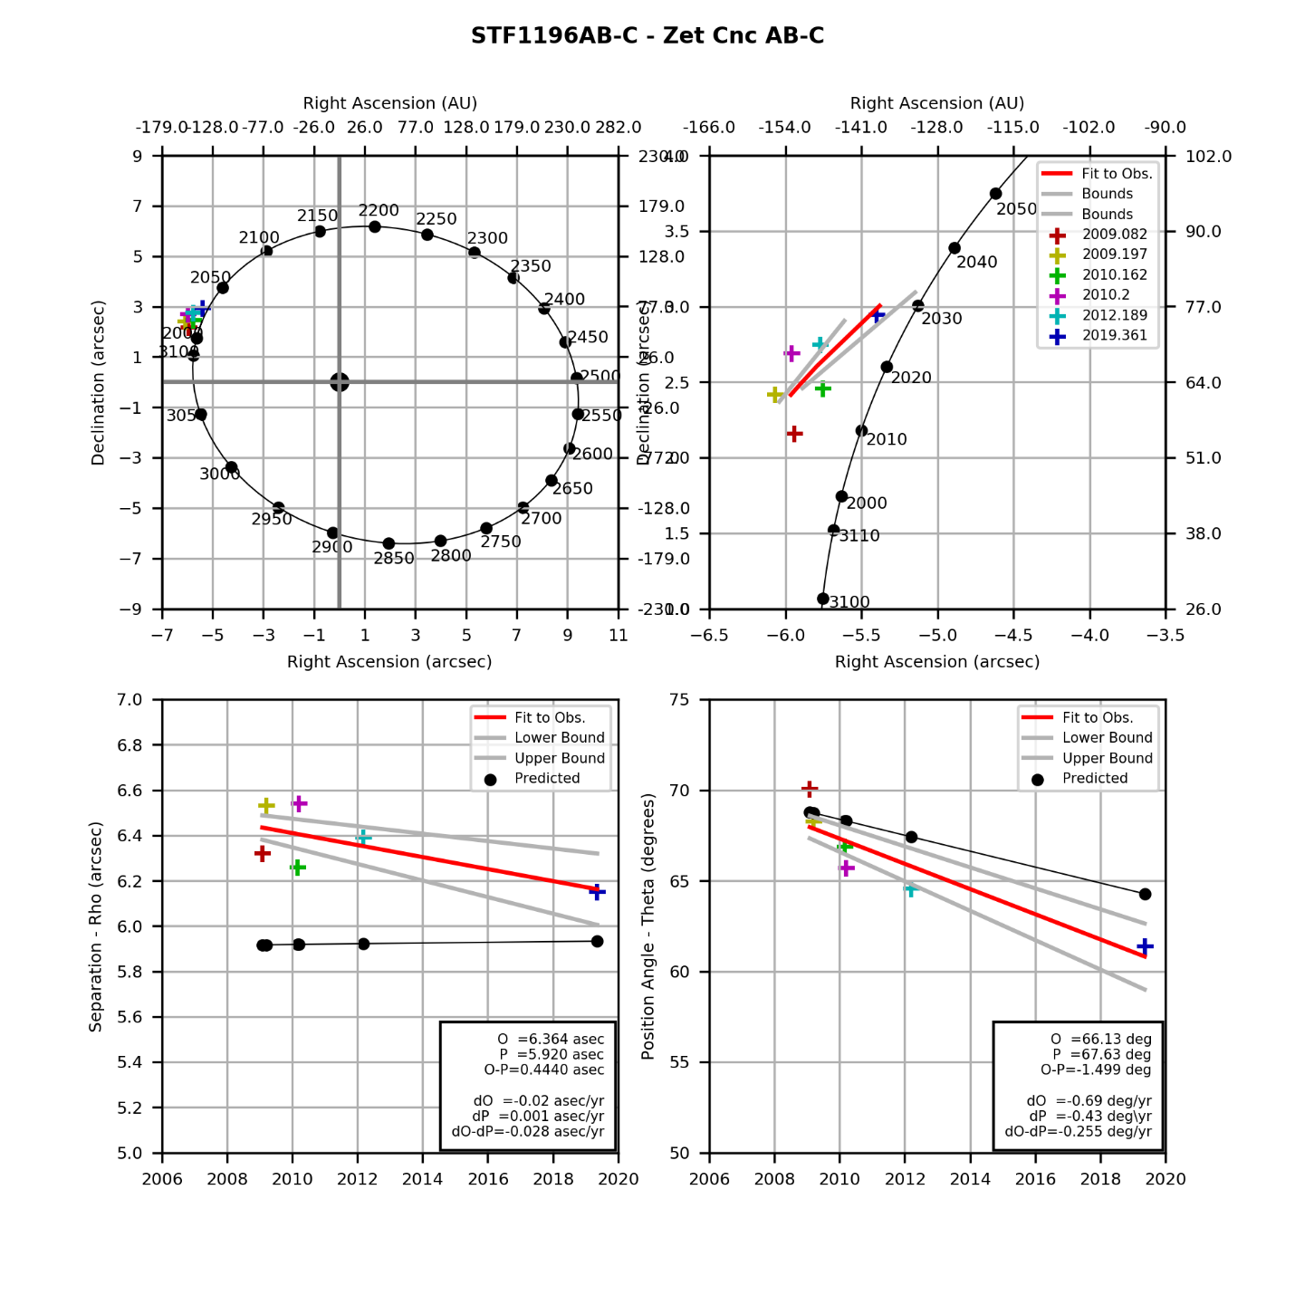

## Hydra Double Stars

|  |  |  |  |  |
| --- | --- | --- | --- | --- |
| **Star** | **First Obs Date** | **Last Obs Dates** | **N Obs** | **Notes** |
| Eps Hyd | 2009.197 | 2010.200 | 2 | Has swept through TBD degrees of PA. |

### Eps Hydrae

|  |  |  |  |  |  |  |  |  |  |  |  |  |  |  |  |  |  |  |  |  |  |  |  |  |  |  |  |  |  |
| --- | --- | --- | --- | --- | --- | --- | --- | --- | --- | --- | --- | --- | --- | --- | --- | --- | --- | --- | --- | --- | --- | --- | --- | --- | --- | --- | --- | --- | --- |
|  | |  |  |  |  | | --- | --- | --- | --- | | **Parameter** | **Value** | **Rate** | **Units** | | PA(O) |  |  | deg(/yr) | | PA(P) |  |  | deg(/yr) | | PA (O-P) |  |  | deg(/yr) | | Sep(O) |  |  | asec(/yr) | | Sep(P) |  |  | asec(/yr) | | Sep (O-P) |  |  | asec(/yr) | |

## Ursa Major Double Stars

|  |  |  |  |  |
| --- | --- | --- | --- | --- |
| **Star** | **First Obs Date** | **Last Obs Dates** | **N Obs** | **Notes** |
| Mizar | 2008.534 | 2008.534 | 1 | Fixed double |
| Xi UMa | 2008.285 | 2012.260 | 5 | Has swept through TBD degrees of PA. |

### Mizar

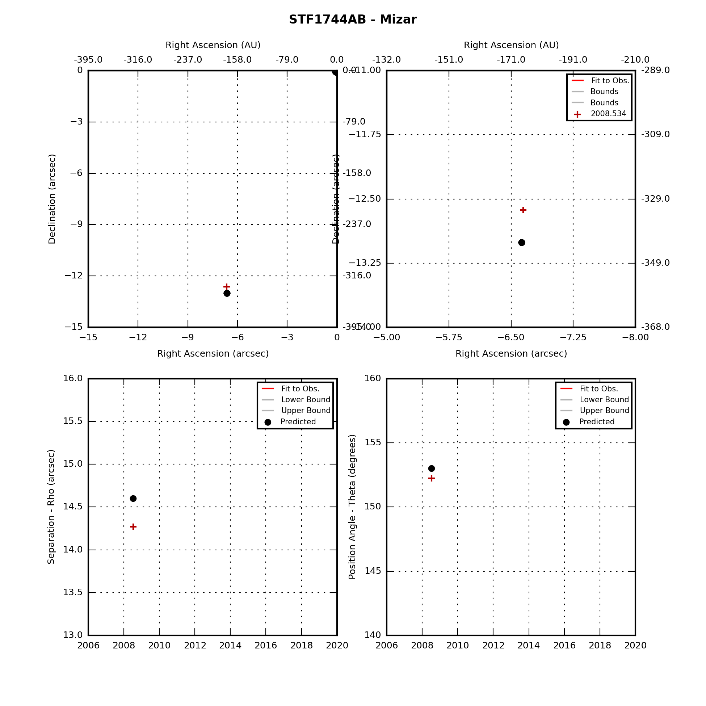

### Xi Uma

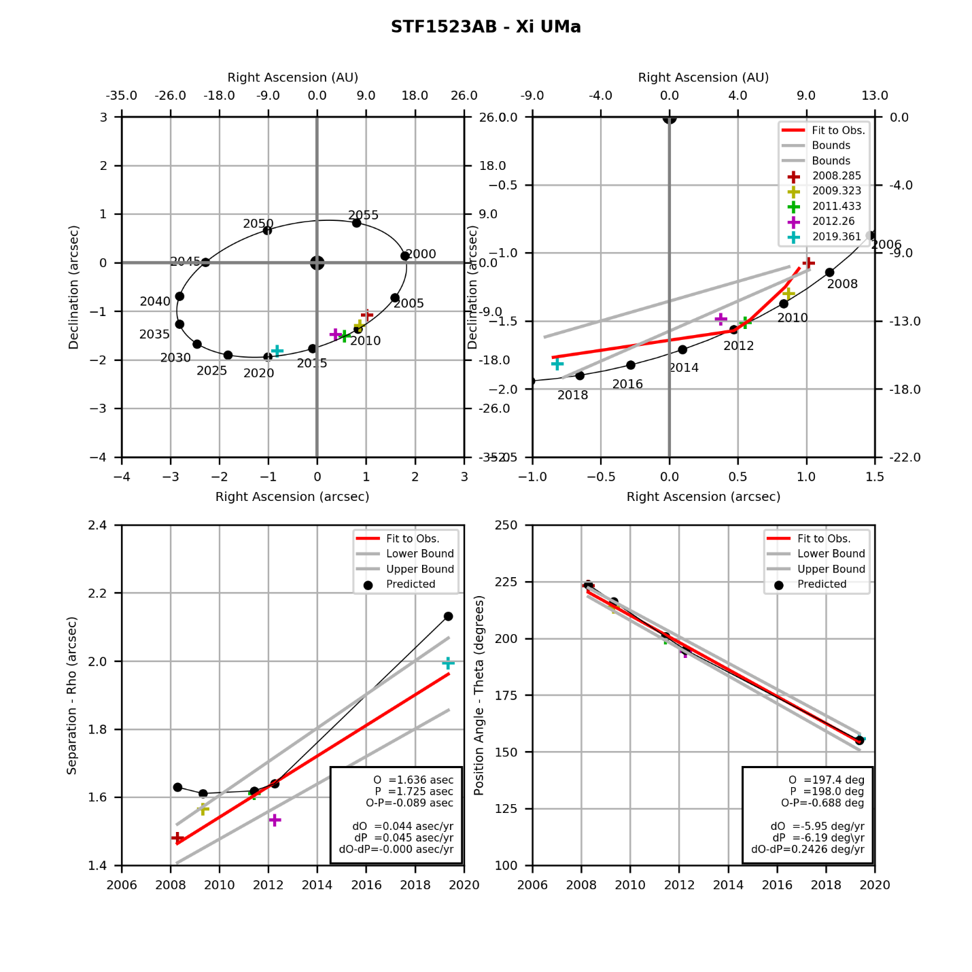

## Leo Double Stars

|  |  |  |  |  |
| --- | --- | --- | --- | --- |
| **Star** | **First Obs Date** | **Last Obs Dates** | **N Obs** | **Notes** |
| Gam Leo | 2008.285 | 2019.361 | 4 | Has swept through TBD degrees of PA. |
| Iot Leo | 2009.323 | 2019.361 | 3 | Has swept through TBD degrees of PA. |
| 54 Leo | 2009.323 | 2009.323 | 1 | Fixed double |

### Gam Leo

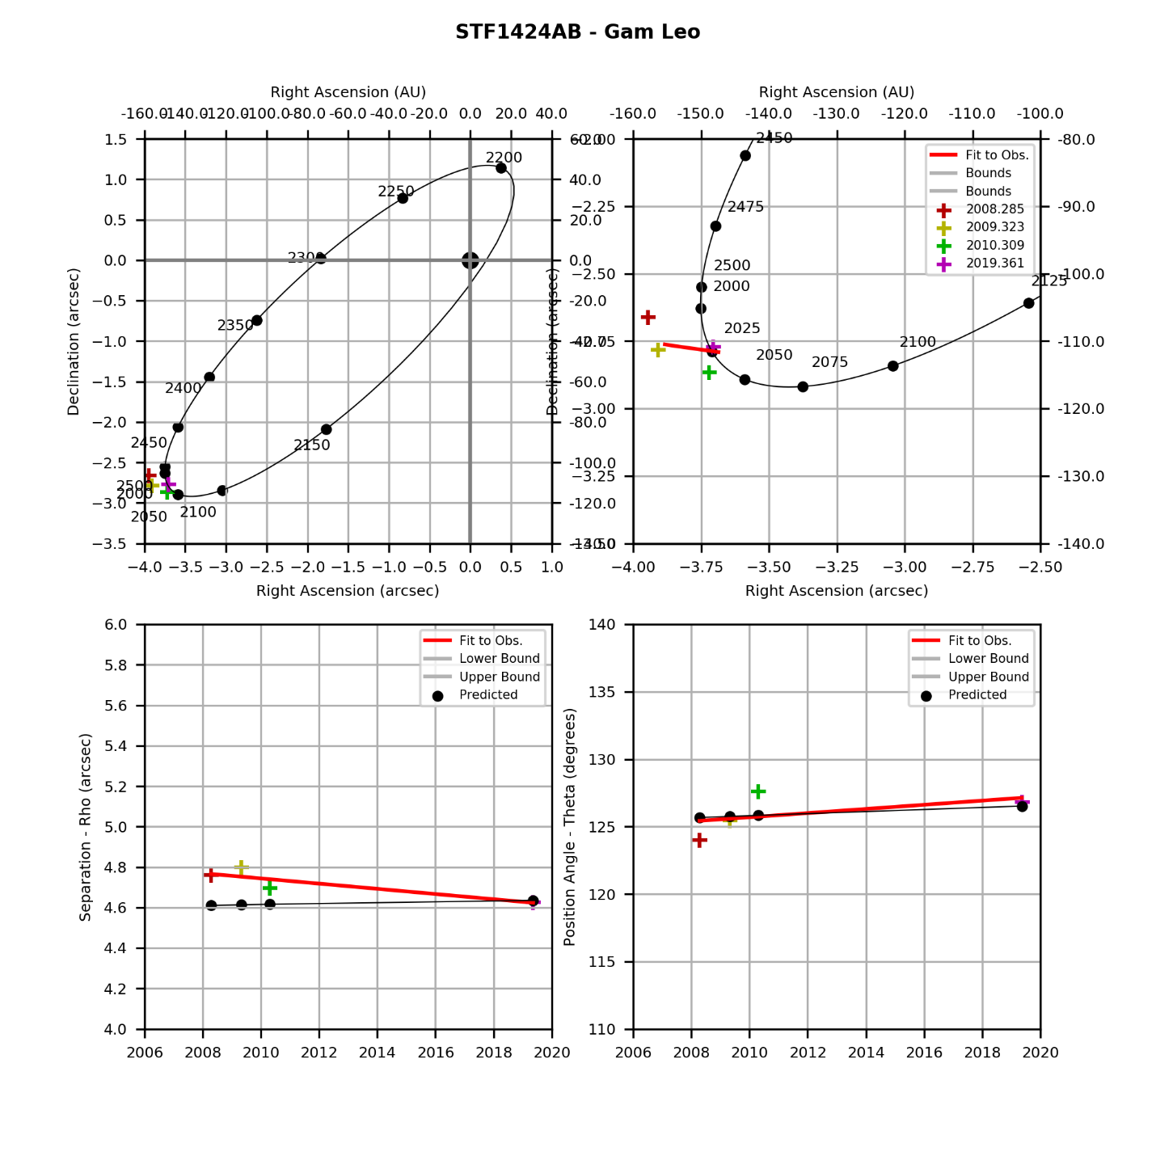

### Iot Leo

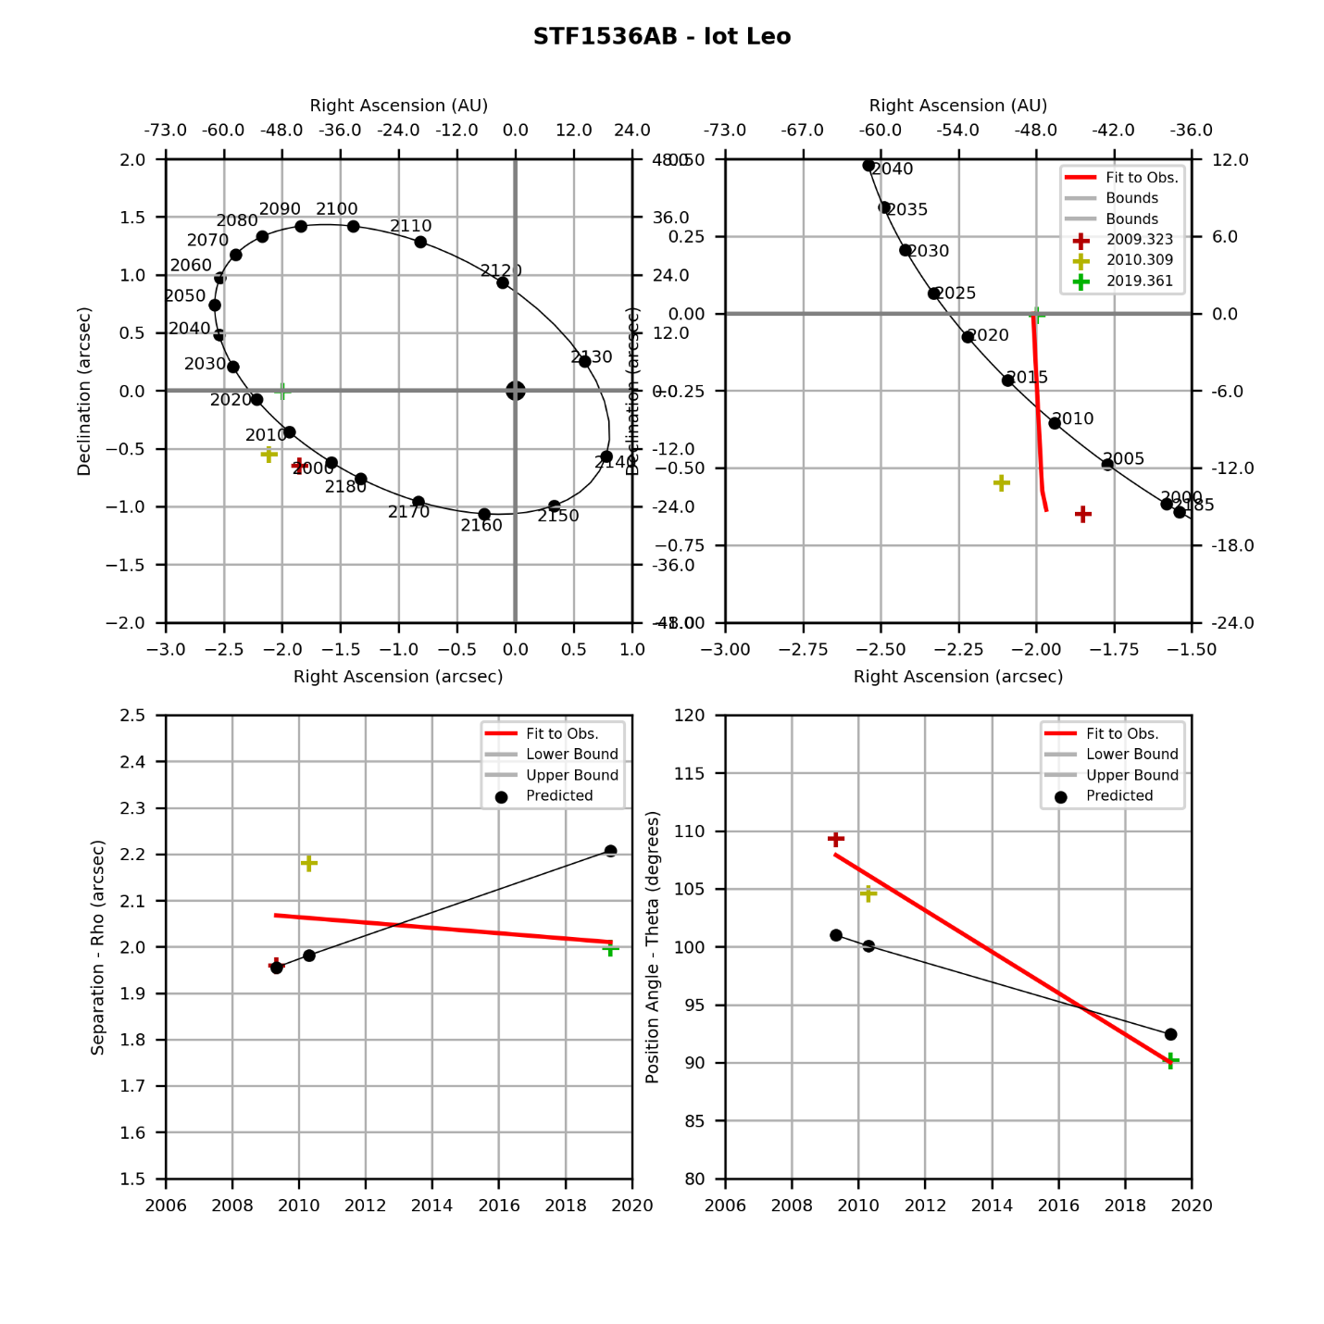

### 54 Leo

|  |  |  |  |  |  |  |  |  |  |  |  |  |  |  |  |  |  |  |  |  |  |  |  |  |  |  |  |  |  |
| --- | --- | --- | --- | --- | --- | --- | --- | --- | --- | --- | --- | --- | --- | --- | --- | --- | --- | --- | --- | --- | --- | --- | --- | --- | --- | --- | --- | --- | --- |
|  | |  |  |  |  | | --- | --- | --- | --- | | **Parameter** | **Value** | **Rate** | **Units** | | PA(O) |  |  | deg(/yr) | | PA(P) |  |  | deg(/yr) | | PA (O-P) |  |  | deg(/yr) | | Sep(O) |  |  | asec(/yr) | | Sep(P) |  |  | asec(/yr) | | Sep (O-P) |  |  | asec(/yr) | |

## Virgo Double Stars

|  |  |  |  |  |
| --- | --- | --- | --- | --- |
| **Star** | **First Obs Date** | **Last Obs Dates** | **N Obs** | **Notes** |
| Porrima | 2011.433 | 2012.353 | 2 | Has swept through TBD degrees of PA. |

### Porrima

